**Stevenson Champions October 2019 Newsletter**

**C:\Users\Customer\AppData\Local\Microsoft\Windows\INetCache\IE\0N5JAF5Q\Birthday1[1].jpg**

**Hello Stevenson Families!**

Please note that during non-holiday school closings, we hold our care services at the Magnolia Center, (unless otherwise noted). The address is:

**17050 Dorset Avenue, Southfield, MI 48075.**

**September Review:**

. Our special person this month is *Miss Scott!* She has really shown how great she is working with children by keeping an organized program, making sure that each child finishes their homework, presenting hands on activities to engage them and more. She even takes on the responsibility of helping with registration paperwork. Please help us celebrate her.

* Our First Friday Family Night was a fantastic celebration of Hispanic Heritage Month. We danced around a Sombrero, tested our balance skills with a limbo dance and broke a Piñata full of goodies. Tacos were the meal of choice! Thank you **Mrs. Sparks** for the idea! Thank you to all of the parents that came out, participated and donated. Your donations help fund our learning Clubs, Kids In Business Project and our Birthday Book Gifts. Thank you!!!!
* Our first ½ day was awesome! The Tech club experimented with new 3-D Virtual games (soon they will learn to code their own games), the Cooking Club made a snack for everyone and the Fashion Club started designing new clothes for the Barbie dolls. We just purchased a second sewing machine for them to learn how to sew. Can’t wait to see what they will create.
* The Higher Learning Project has started with Study stations and academic games. We reviewed several of the Progress reports that were issued last week and we are developing a strategic plan to help the students to bring up their grades.
* Our Gymnastics Coach is back! It’s not too late to sign up!

**SPECIAL ANNOUNCEMENTS:**

* ***Our next Family Night will be in conjunction with Octoberfest on October 24th*. Join us for a fun time of games, refreshments and fun activities. We may even have a few products available from the *Kids In Business Project*, which begins this month. Please donate at** **$ChampionsKids** **on the CashApp.**
* **Champions is helping with the Scholastic Book fair this year in the Stevenson library from October 18-25th. WE NEED VOLUNTEERS…PLEASE!!! If you prefer to shop online, please order from October at** [**www.scholastic.com/bf/stevensonelementary**](http://www.scholastic.com/bf/stevensonelementary)
* Fire Prevention Week is October 7th-11th. Be sure to change the batteries in your smoke alarms.

**SPECIAL TIP: the Dollar-Tree and Five Below stores have wonderful academic practice books to help improve skills and confidence in school.**

**October Birthdays**

**2nd- Jordyn**

**3rd –Morgan & Pravanya**

**6th-Autumn**

**16th- Amir**

**21st- Austin M.**

**25th- Justin W.**

**26th- Peyton**

**28th – Ana’Laia**



**Our Programs:**

In addition to our quality before and after school care program, Champions offers a wide variety of different programs when there is no school!

* **Before Care** 6:30 a.m. until the start of school.
* **After Care** end of school until 6:00 p.m.
* **Break Programs** –

We offer full day programs during winter break, mid-winter break, spring break and summer break. **We also have 1/2 day programs for the last Wednesday of each month.**

* **Discount-** 10% multi-child discount.

10% SPS employee discount. 10% Military Discount

* **New Families** can register at www.**discoverchampions.com**

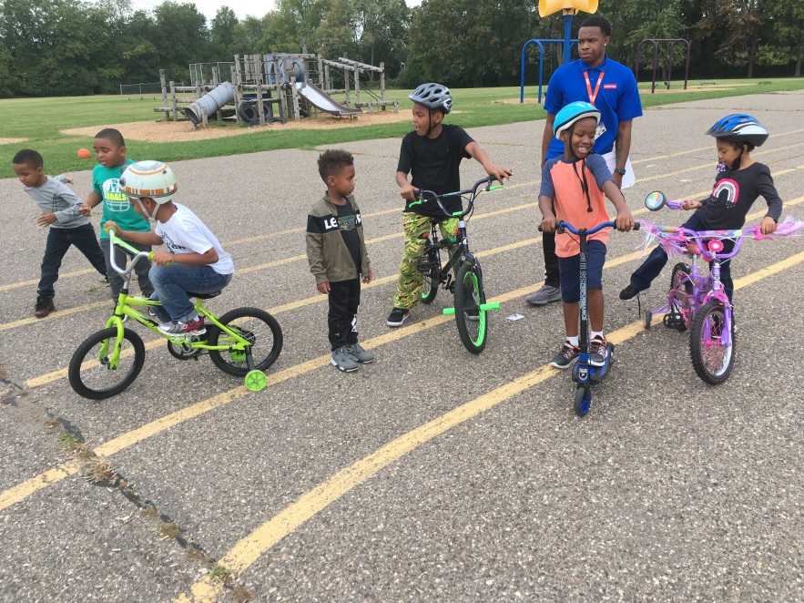

**Rates:**

Registration Fee: $25.00 per child

After Care Session: $10.00

Before Care Session: $6.00

Re-enrollment fee: $20.00

Early Dismissal (1/2 Day) Additional $11.00 until 3:00 plus regular Aftercare session fee after 3:00.

Late pay fee: $10.00 per week. Tuition is due every Wednesday of each week.

Late pick up fee: 6:01-6:15pm $10.00; 6:16pm-6:30pm $20.00; 6:31pm-6:45pm $30.00; 6:46pm-7:00pm $40.00. per child.

**Break Programs: full day only option $34.00 per child per day.**

**PICTURE OF THE MONTH:**

WHEELIE DAY! Every half day with good weather is Wheelie day. There’s nothing like riding with your friends. The next ½ day is October 30th

**Southfield Champions**

**Site Name: Stevenson Elementary_**

**Site: #_4035________________**

**Staff: Mrs. Rand- SouthfieldField Coach, Director and 4th-5th Grade Teacher** [KRand@discoverchampions.com](mailto:KRand@discoverchampions.com)

**Mr. Morris- 2nd & 3rd Grade Teacher**

**Miss Scott- Kindergarten Teacher**

**Miss Bills- 1st Grade Teacher**

**Site Phone: __248.794.2071**

**Operating Hours:**

**6:30 a.m. - 8:00 a.m.**

**3:00 p.m. - 6:00 p.m.**

**Champions Contact Info Here**

**Main Office: 248-395-0484**

**Site Cell: 248.794.2071**

**Fax: 248-395-0486**

**Customer Care: 1-800-350-5034**

**Local Contact **

**Emergency: 911**

**Southfield Fire Department:**

**248-796-5650**

**Southfield Police Department:**

**248-796-5500**

**Poison Control:**

**1-800-222-1222**