**Stevenson Champions November 2019 Newsletter**

**C:\Users\Customer\AppData\Local\Microsoft\Windows\INetCache\IE\0N5JAF5Q\Birthday1[1].jpg**

**Hello Stevenson Families!**

Please note that during non-holiday school closings, we hold our care services at the Magnolia Center, (unless otherwise noted). The address is:

**17050 Dorset Avenue, Southfield, MI 48075.**

**October Review:**

Our special person this month is ***Austin****!* He has demonstrated great effort in being a stellar student. He helps the teachers without being asked, never hesitates to get to his homework and even fixed another student’s bike on Wheelie Day. Austin even volunteers to read to the other students at reading time. We are so proud of him!

* Family night was part of the Stevenson October-fest. There were so many activities, everyone had a great time.
* The Book-fair was our community project. The students took time to unpack all of the boxes of books, hang posters, stuff bags with fliers and more.
* We worked on our Kindness Card project. Throughout the weeks, we took time to randomly pass out name cards for each child to write something favorable. I got a chance to read the cards to everyone and the children really appreciated what they heard from their peers. Kindness is key.
* Our last two curriculum units focused on “***Gross and Gooey Physiology***” and “***Pop Art***”. The children learned how our organs work together and how our emotions are affected by creating and appreciating art. This month’s units are “***Simple Machines***” and “***Weather and Natural Disasters***”.
* Students that are struggling with reading are being given an opportunity to get help. Please contact the Stevenson office for more information if you missed signing up for the **I.R.I.P** program. Ask for Mrs. Jones or Mrs. Rourke.
* We have a bitter-sweet farewell to our dear Miss Bills. She has the opportunity to pursue a great internship. We are thrilled for her, but sorry to see her go.
* Please help us welcome our new teacher, Mrs. Stewart, to our team.

**SPECIAL ANNOUNCEMENTS:**

* ***Our next Family Night will be Friday, November 22nd*. Join us for our annual “*Parent Honors Dinner*”. Dress up, bring the whole family out and get ready for a great night where the children present special gifts and talents to honor their parents.**
* This month is National Novel Writing Month. What a great time to encourage your child to share their great stories.
* **The Book fair will still be open online until November 8th. There are several phonics book sets that I strongly recommend for beginning readers.**

**SPECIAL TIP: Posting sight-words around your home is a great way to increase your child’s vocabulary. For older children, try posting positive statements or poetry at stationary locations. The bathroom, laundry room or over the sink where they wash dishes are great spaces.**

**November Birthdays**

**8th – TaNiyah**

**15th - Airris**

**21st – Jade**

**22nd – Jordan M.**

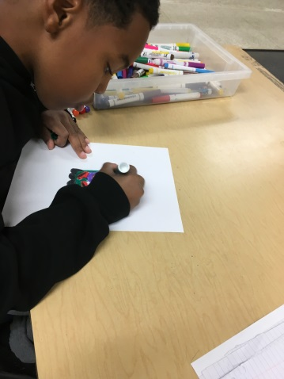

**Our Programs:**

In addition to our quality before and after school care program, Champions offers a wide variety of different programs when there is no school!

* **Before Care** 6:30 a.m. until the start of school.
* **After Care** end of school until 6:00 p.m.
* **Break Programs** –

We offer full day programs during winter break, mid-winter break, spring break and summer break. **We also have 1/2 day programs for the last Wednesday of each month.**

* **Discount-** 10% multi-child discount.

10% SPS employee discount. 10% Military Discount

* **New Families** can register at www.**discoverchampions.com**

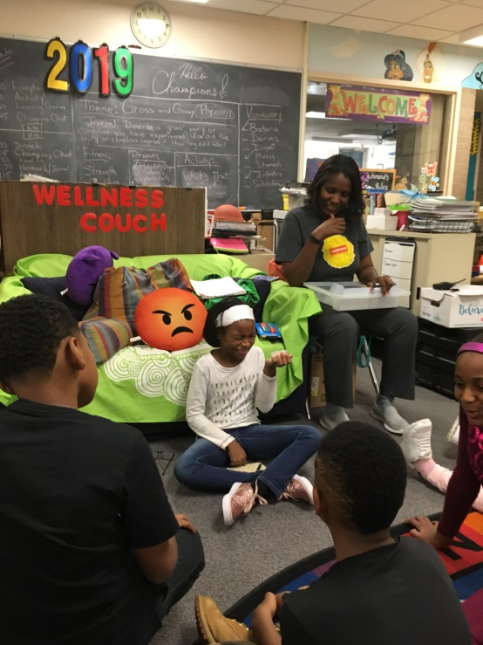

**Rates:**

Registration Fee: $25.00 per child

After Care Session: $10.00

Before Care Session: $6.00

Re-enrollment fee: $20.00

Early Dismissal (1/2 Day) Additional $11.00 until 3:00 plus regular Aftercare session fee after 3:00.

Late pay fee: $10.00 per week. Tuition is due every Wednesday of each week.

Late pick up fee: 6:01-6:15pm $10.00; 6:16pm-6:30pm $20.00; 6:31pm-6:45pm $30.00; 6:46pm-7:00pm $40.00. per child.

**Break Programs: full day only option $34.00 per child per day.**

**PICTURE OF THE MONTH:**

For the “Gross and Gooey Physiology” curriculum unit, students were asked to identify common smells from sample cups. Their reactions were priceless!

**Southfield Champions**

**Site Name: Stevenson Elementary_**

**Site: #_4035________________**

**Staff: Mrs. Rand- Southfield Field Coach, Director and 3rd -5th Grade Teacher** [KRand@discoverchampions.com](mailto:KRand@discoverchampions.com)

**Miss Scott- Kindergarten- 1st Grade Teacher**

**Miss Stewart- 1st – 2nd Grade Teacher**

**Site Phone: __248.794.2071**

**Operating Hours:**

**6:30 a.m. - 8:00 a.m.**

**3:00 p.m. - 6:00 p.m.**

**Champions Contact Info Here**

**Main Office: 248-395-0484**

**Site Cell: 248.794.2071**

**Fax: 248-395-0486**

**Customer Care: 1-800-350-5034**

**Local Contact **

**Emergency: 911**

**Southfield Fire Department:**

**248-796-5650**

**Southfield Police Department:**

**248-796-5500**

**Poison Control:**

**1-800-222-1222**