**Stevenson Champions March 2020 Newsletter**



 **Hello Stevenson Families!**

Please note that during non-holiday school closings, we hold our care services at the Magnolia Center, (unless otherwise noted). The address is:

**17050 Dorset Avenue, Southfield, MI 48075.**

**March Review**

* Our special person of the month is **Kaitlyn**! She is such a kind person and very willing to help. She is a good listener, is caring to others and so much fun to be around. Let’s celebrate her!
* February’s **“*Family Night***” was cancelled due to the snow day! We will reschedule for this month on Wednesday, the 18th at 6:00pm.
* The children’s curriculum unit for February was *American Folk Music*, which gave us an opportunity to explore culture and history from a fun, musical perspective. We have noticed more students taking an interest in our Music Club. Because music is so key to helping students develop focus, math skills, coordination and discipline, I highly recommend you consider music lessons for an instrument of your child’s choice. Music study makes other subjects in school a lot easier to comprehend. Online courses, mobile music game apps (which are a much better alternative to games involving fighting) and the local music stores, such as [*The Guitar Center*](https://stores.guitarcenter.com/southfield?source=4SOSWXXN) offer great opportunities to learn.
* *The Tech Track* technology unit of study is going well. We are about to begin Module 3. The students have already learned the basics of coding, robotics, video creation and computer graphics. Now we will learn to hone the skill of creating art with various apps.

**SPECIAL ANNOUNCEMENTS:**

* ***Our next Family Night is Wednesday, March 18th.*  Per popular request, we will visit the skating rink (since we were snowed out last month) at Northland Skating Rink at 22311 M-102, Detroit, MI 48219. The outing from 6:00-8:00pm and children under 12 have FREE admission with a paying adult and skate rental is only $3.00.**
* This month is National Reading Month.  We will need volunteers for the ***Scholastic Book-fair*** which will be held from **March 27th-April 2nd**.  Grandparents, we will have a special day to celebrate you on March 31st.  Please consider signing up to read to your grandchild's class. There is also a Mini-Book-fair this week and books are only $3.00 each or 2 for $5.00.
* **March 25th is the next ½ day. The theme will be “My Favorite S’Hero” in honor of Women’s History Month. The children will have a chance to celebrate the women in their lives that they most admire with special activities.**
* Registration for Spring Break and Summer Camp is now open online. Fall 2020-2021 will open soon. Get ready!

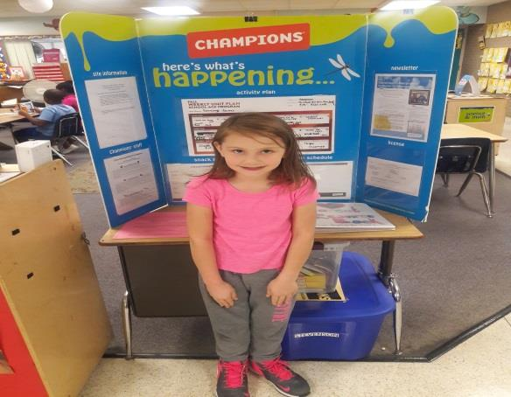

**Our Programs:**

In addition to our quality before and after school care program, Champions offers a wide variety of different programs when there is no school!

* **Before Care** 6:30 a.m. until the start of school.
* **After Care** end of school until 6:00 p.m.
* **Break Programs** –We offer full day programs during winter break, mid-winter break, spring break and summer break. **We also have 1/2 day programs for the last Wednesday of each month.**
* **Discount-** 10% multi-child discount.

10% SPS employee discount. 10% Military Discount

* **New Families** can register at www.**discoverchampions.com**

**March Birthdays**

**22nd- Christian**

**26th -Ernest**

**Local Contact** 

**Emergency: 911**

**Southfield Fire Department:**

**248-796-5650**

**Southfield Police Department:**

**248-796-5500**

**Poison Control:**

**1-800-222-1222**

**Champions Contact Info Here**

**Main Office: 248-395-0484**

**Site Cell: 248.794.2071**

**Fax: 248-395-0486**

**Customer Care: 1-800-350-5034**

**Southfield Champions**

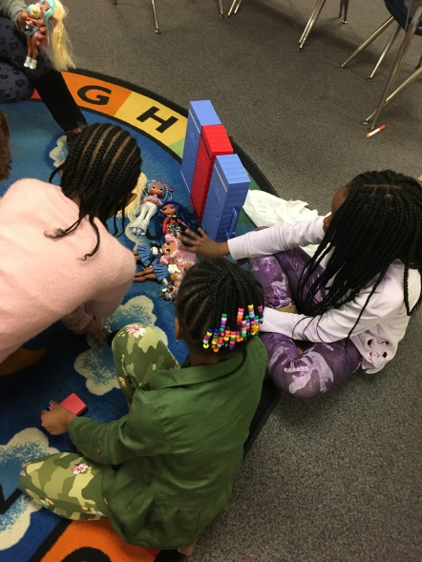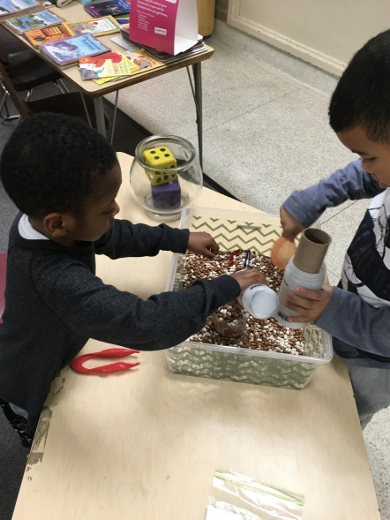



**Rates:**

Registration Fee: $25.00 per family

After Care Session: $10.00

Before Care Session: $6.00

Re-enrollment fee: $20.00

Early Dismissal (1/2 Day) Additional $11.00 until 3:00 plus regular Aftercare session fee after 3:00.

Late pay fee: $10.00 per week. Tuition is due every Wednesday of each week.

Late pick up fee: 6:01-6:15pm $10.00; 6:16pm-6:30pm $20.00; 6:31pm-6:45pm $30.00; 6:46pm-7:00pm $40.00. per child.

**Break Programs: full day only option $34.00 per child per day.**

**PICTURES OF THE MONTH:**

**The students take enjoy different sensory activities that stimulate fine motor skills and increase interest in math and science. On Friday’s and ½ days, the students enjoy bringing their own toys for Show and Share.**

**Site Name: Stevenson Elementary**

**Site: #4035**

**Staff: Mrs. Rand- Southfield Field Coach, Director and 4th-5th Grade Teacher** [KRand@discoverchampions.com](mailto:KRand@discoverchampions.com)

**Mr. Morris- 2nd & 3rd Grade Teacher**

**Miss Scott- Kindergarten Teacher**

**Mrs. Stewart- 1st -2nd Grade Teacher**

**Miss Golden –Group Teacher (a.m.)**

**Site Phone: 248.794.2071**

**Operating Hours:**

**6:30 a.m. - 8:00 a.m.**

**3:00 p.m. - 6:00 p.m.**