**Stevenson Champions** June **2019 Newsletter**

**C:\Users\Customer\AppData\Local\Microsoft\Windows\INetCache\IE\0N5JAF5Q\Birthday1[1].jpg**

** Hello Stevenson Families!**

Please note that (unless otherwise noted), Summer Camp will be held at the Birney Middle School, The address is:

**27225 Evergreen Road, Southfield, MI 48076.**

**2018-2019 School Year In Review:**

I don’t know how, but this year has gone by really fast. A lot has happened and I hope we made an impact in the lives of the children and their families.

* Our monthly “**First Friday Family Nights**” included Safety ID Night, Game Night, The Parent Honors Dinner, Healthy-Wealthy-Wise Seminar, Family Heritage Night, Let’s Make A Deal Game-show and Kite-Night. We also took 1st Day Pictures to surprise the parents.
* **The Kids In Business** Project featured the development of over a dozen businesses created and operated by the students.
* **The Public Act 306 Reading Project** was where we read with and to the children for 15-20 minutes every day to improve their reading ability. Report cards showed improvements for many students.
* **Community Service** projects included helping Stevenson with October-fest, hosting two Book-fairs and creating a Summer Camp Scholarship through our school-wide “Let’s Make A Deal” project.
* **Bonus Day** awarded the students for demonstrating exceptional character, skill and initiative with prizes.
* We set up “**Study Station**” time every morning to help children with varying academic challenges by providing several academic games and activities. We have noticed improved grades for several students this year.
* **Wheelie Day** was introduced this year where the children brought their skates, scooters and bikes to enjoy their time here when the school had half days.
* We introduced the **Gymnastics** with Coach Kendyl program to help the children develop discipline and increase their focus.
* For the second year in a row, not one child suffered a major injury in our care. Have a safe and wonderful Summer! We’ll miss you!

**SPECIAL ANNOUNCEMENTS:**

* Kindergarten and 5th Graders do not need to be scheduled after their graduation dates of the 12th and 13th. Please update your account.
* **There is no PM care on the last day of school, June 14th.**
* **June 18th – August 21st Summer Camp begins at the Birney Middle School from 6:30-6:00 daily. Camp is closed on July 4th.**
* School Re-Opens on Monday, August 26, 2019. We will be ready for you at Champions at 6:30am sharp! We can’t wait!
* ***Our next Friday Family Night* will beFriday,September 6th. Join us for a special Orientation meeting to prepare for the new school year as we implement new endeavors.**

**SPECIAL TIP:** This Summer, if your children swim, please familiarize yourself with the symptoms of “[Dry Drowning](https://www.webmd.com/children/features/secondary-drowning-dry-drowning#1)”. It is rare, but we must be aware! For more information see:

https://www.webmd.com/children/features/secondary-drowning-dry-drowning#1

**June Birthdays**

**4th –Lauriana**

**7th – McKenlee**

**10th –Mark**

**13th –Jadyn**

**18th – Jayla**

**26th –Alex**

**27th –Zaria**

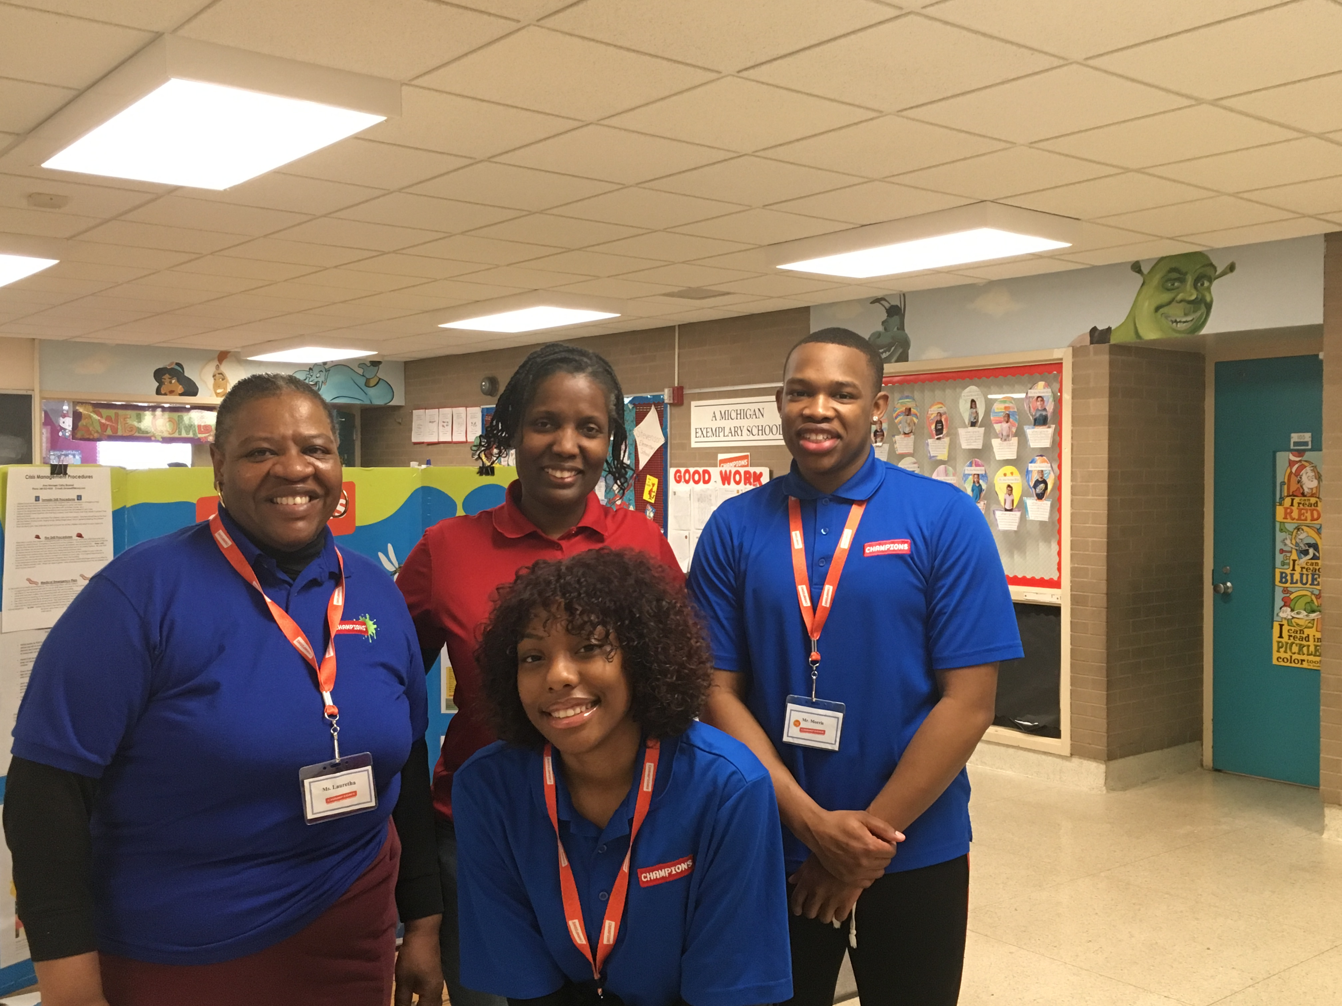

**Our Programs:**

In addition to our quality before and after school care program, Champions offers a wide variety of different programs when there is no school!

* **Before Care** 6:30 a.m. until the start of school.
* **After Care** end of school until 6:00 p.m.
* **Break Programs** –

We offer full day programs during winter break, mid-winter break, spring break and summer break. **We also have 1/2 day programs for the last Wednesday of each month.**

* **Discount-** 10% multi-child discount.

10% SPS employee discount. 10% Military Discount

* **New Families** can register at www.**discoverchampions.com**



**Local Contact **

**Emergency: 911**

**Southfield Fire Department:**

**248-796-5650**

**Southfield Police Department:**

**248-796-5500**

**Poison Control:**

**1-800-222-1222**

**2018-19 Champions Team:**

* **Mrs. Catherine Broessel (Area Manager)**
* **Mrs. Kesha Rand (Director and 4th-5th Grade)**
* **Mr. Anthony Morris (2nd-3rd Grade)**
* **Miss. D’Nesha Scott (K-1st Grade)**
* **Miss Jackie Cade**
* **Mrs. Brittnie Wilson**
* **Ms. Alisha Raiford**
* **Ms. Angela Cope**
* **Miss Jaria Wells**
* **Ms. Sumalia Gandy**
* **Miss Sarena Caver**
* **Ms. Lauretha Shelton**
* **Ms. Debra Davis**
* **Ms. Jill Armenteros**
* **Miss Alison Ogelsby**

**Champions Contact Info Here**

**Main Office: 248-395-0484**

**Site Cell: 248.794.2071**

**Fax: 248-395-0486**

**Customer Care: 1-800-350-5034**

**Site Phone: __248.794.2071___________________**

**Operating Hours:**

**6:30 a.m. - 8:00 a.m.**

**3:00 p.m. - 6:00 p.m.**

**www.discoverchampions.com**

**Southfield Champions**