**Stevenson Champions January 2020 Newsletter**



**January Birthdays**

**1st – Wesley**

**4th – NoElle**

**5th - Airamus**

**10th– Miss Scott**

**24th- Amya**

**28th- Austin**

**30th- Mrs. Rand**

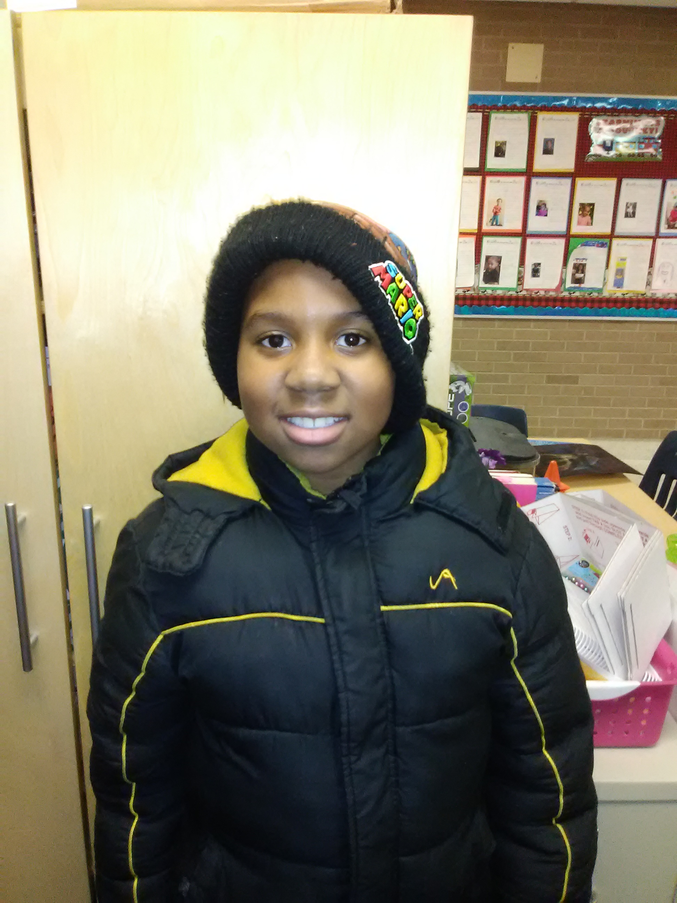

**Our Programs:**

In addition to our quality before and after school care program, Champions offers a wide variety of different programs when there is no school!

* **Before Care** 6:30 a.m. until the start of school.
* **After Care** end of school until 6:00 p.m.
* **Break Programs** –We offer full day programs during winter break, mid-winter break, spring break and summer break. **We also have 1/2 day programs for the last Wednesday of each month.**
* **Discount-** 10% multi-child discount.

10% SPS employee discount. 10% Military Discount

* **New Families** can register at www.**discoverchampions.com**

** Happy New Year Stevenson Families!**

Please note that during non-holiday school closings, we hold our care services at the Magnolia Center, (unless otherwise noted). The address is:

**17050 Dorset Avenue, Southfield, MI 48075.**

**December Review:**

* Our special person of the month is Asaiah Williams! He has been a tremendous help as a Patrol at the Bookfair and the Santa Shop. He is a studious, Straight-A student and even goes out of his way to help other students struggling with homework. Help us celebrate him!
* December’s **“*Family Night***” was a great time of music, fun and exercise. 60 members of our families and staff came together for a great Skate Night at Northland. One of our students, TaNiyah, won a brand new pair of $80 Roller skates!!! Thank you all for such a great turn out of Dads, Moms, Grandparents and Siblings. It was so much fun!
* The children’s curriculum unit for December was *Building Bridges*. While we focused on the dynamics of physical bridges, as a Project-Based Learning activity we focused on building social bridges and converted the old Teacher’s Lounge/Storage room into a new ***Legacy Wellness Lounge*** for the Teachers. We wanted to always remind the teachers of how important they are. The children made artwork, created a giant card, wrote essays, helped to set up, cleaned the room and donated 10% of the proceeds from their businesses to the project. Thanks also go to Mrs. Murphy for helping set up and donating some of the decorations and snacks.
* The children had a very successful Business Bazaar and a few of our little Entrepreneurs sold out of their products. Congratulations go out to :

1. **Gift Mugs (owned by Mariah J., Peyton, Londyn M. and Izenebu) SOLD OUT!**
2. **Slime (owned by Christian, KaMyra and NoElle) SOLD OUT!**
3. **Paper Airplanes (owned by Donovan C., Donaven H. and Myles)**
4. **Handmade Jewelry (owned by McKenlee & Skyla D.)**
5. **Handcrafted Beauty Products (owned by Danee-Lynn, Amya & Joy)**
6. **Popcorn (owned by Kenyon, Asaiah, Aria & Autumn) SOLD OUT!**
7. **Bling Strings (owned by Jade)**
8. **Origami Art Stars (owned by Austin, Brandon & Alex)**
9. **Hand Designed Frames (owned by the K-1st Grade Group)**

**SPECIAL ANNOUNCEMENTS:**

* ***Our next First Friday Family Night is January 30th as we celebrate Mrs. Rand’s Karaoke birthday.*** The party will begin at 5:30 on Thursday, January 30th. Parents too!**. We would like each child to bring a $5 gift to exchange. Girls bring a girl-gift and boys a boy-gift. Warm up your voices, there will be prizes for the best singer.**
* **We are adding a new extension of our curriculum this month focusing on STEM including robotics, coding, engineering and design. Get your fliers today.**
* **School is closed for the holiday break from January 20th - 21st to celebrate Dr. King day and records day . We will only have care available on Tuesday, the 21st at the Magnolia Center.**

**Southfield Champions**

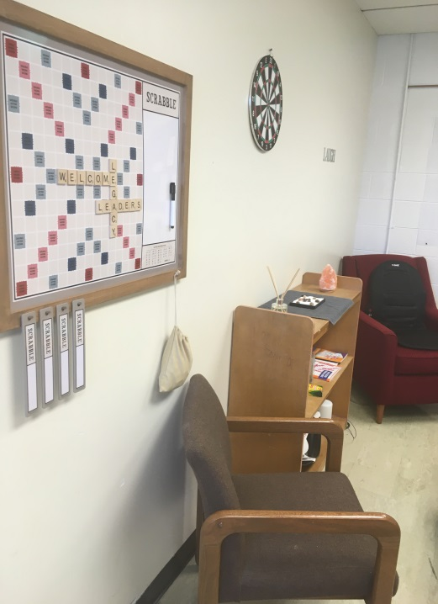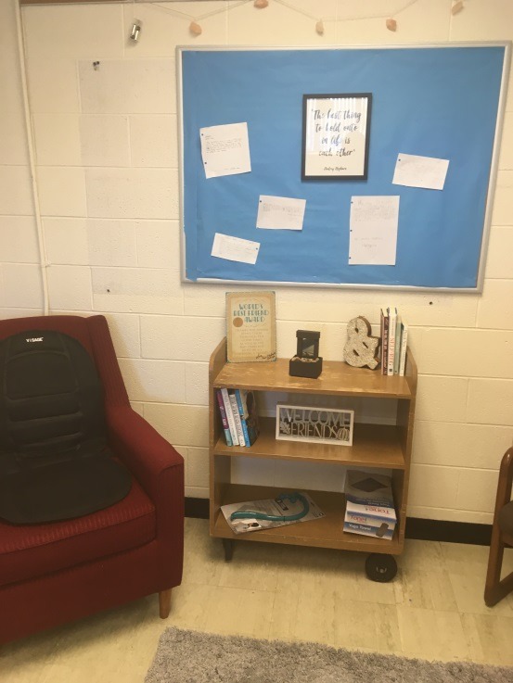

**Site Name: Stevenson Elementary**

**Site: #4035**

**Staff: Mrs. Rand- Southfield Field Coach, Director and 4th-5th Grade Teacher** [KRand@discoverchampions.com](mailto:KRand@discoverchampions.com)

**Mr. Morris- 2nd & 3rd Grade Teacher**

**Miss Scott- Kindergarten Teacher**

**Mrs. Stewart- 1st -2nd Grade Teacher**

**Site Phone: 248.794.2071**

**Operating Hours:**

**6:30 a.m. - 8:00 a.m.**

**3:00 p.m. - 6:00 p.m.**

**Rates:**

Registration Fee: $25.00 per child

After Care Session: $10.00

Before Care Session: $6.00

Re-enrollment fee: $20.00

Early Dismissal (1/2 Day) Additional $11.00 until 3:00 plus regular Aftercare session fee after 3:00.

Late pay fee: $10.00 per week. Tuition is due every Wednesday of each week.

Late pick up fee: 6:01-6:15pm $10.00; 6:16pm-6:30pm $20.00; 6:31pm-6:45pm $30.00; 6:46pm-7:00pm $40.00. per child.

**Break Programs: full day only option $34.00 per child per day.**

**PICTURES OF THE MONTH:**

**This is a glimpse into the *Legacy Wellness Lounge* that the children created as a group project. The teachers really love it. It is so important to give back!**

**Champions Contact Info Here**

**Main Office: 248-395-0484**

**Site Cell: 248.794.2071**

**Fax: 248-395-0486**

**Customer Care: 1-800-350-5034**

**Local Contact **

**Emergency: 911**

**Southfield Fire Department:**

**248-796-5650**

**Southfield Police Department:**

**248-796-5500**

**Poison Control:**

**1-800-222-1222**