**Stevenson Champions February 2020 Newsletter**



**February Birthdays**

**2nd - Aria**

**12th - Preston**

**11th - Skyla**

**19th–Miss Golden**

**27th – Jayce**

**28th – Carter S.**

 **Hello Stevenson Families!**

Please note that during non-holiday school closings, we hold our care services at the Magnolia Center, (unless otherwise noted). The address is:

**17050 Dorset Avenue, Southfield, MI 48075.**

**January Review:**

* Our special person of the month is **Keonna**! She is a very caring, sweet and cheerful young lady who brings a smile to everyone in the room. She always listens to her teachers, plays fairly and cares for the other students. She is such a joy to teach!
* January’s **“*Family Night***” was so exciting! We celebrated Mrs. Rand’s birthday with a Karaoke party! The parents and students participated with lots of singing, laughing and food! Thank you for making this night special.
* The children’s curriculum unit for January was Advertising and learning to navigate with Maps. To understand the difference between truth in advertising and basic marketing will help them make better choices as consumers.
* Our ½ Day had a “Motown Theme” and the students either dressed up in costumes or wore masks to create our own “Masked Singer” experience. It was so much fun to see the children support each other’s talents in singing.
* *The Higher Learning Project* has been restarted to help the students that are struggling academically. This includes special learning games, study skills tips, academic challenges, more visual aids and hands-on demonstrations.

**SPECIAL ANNOUNCEMENTS:**

* ***Our next Family Night is February 26th.*  Per popular request, we will visit the skating rink again at Northland Skating Rink at 22311 M-102, Detroit, MI 48219. The outing from 6:00-8:00pm and children under 12 have FREE admission with a paying adult and skate rental is only $3.00.**
* School is closed for the holiday break from February 17th - 21st for the Mid-Winter break. Students grades 3rd -5th will be allowed to borrow books to read over the break and will receive Bonus Points for completion. If you need care during the week at the Magnolia Center, please sign up on your account.
* **February 26th is the next ½ day. The theme will be “Wakanda Forever” in honor of Black History Month. Students may bring items based on that theme and wear RED or dress up as a character from the movie. Your help is needed for this in order to make it really special. The Photography, Dance and the Fashion clubs will help us film our own (non-violent) version of the movie “Black Panther” and we will show it at our March Family Night. Sign up at the Parent Center.**
* Registration for Spring Break and Summer Camp is now open online. Summer camp registration fees will be delayed until May if you register by February 28th.



**Our Programs:**

In addition to our quality before and after school care program, Champions offers a wide variety of different programs when there is no school!

* **Before Care** 6:30 a.m. until the start of school.
* **After Care** end of school until 6:00 p.m.
* **Break Programs** –We offer full day programs during winter break, mid-winter break, spring break and summer break. **We also have 1/2 day programs for the last Wednesday of each month.**
* **Discount-** 10% multi-child discount.

10% SPS employee discount. 10% Military Discount

* **New Families** can register at www.**discoverchampions.com**

**Champions Contact Info Here**

**Main Office: 248-395-0484**

**Site Cell: 248.794.2071**

**Fax: 248-395-0486**

**Customer Care: 1-800-350-5034**

**Local Contact** 

**Emergency: 911**

**Southfield Fire Department:**

**248-796-5650**

**Southfield Police Department:**

**248-796-5500**

**Poison Control:**

**1-800-222-1222**

**Southfield Champions**

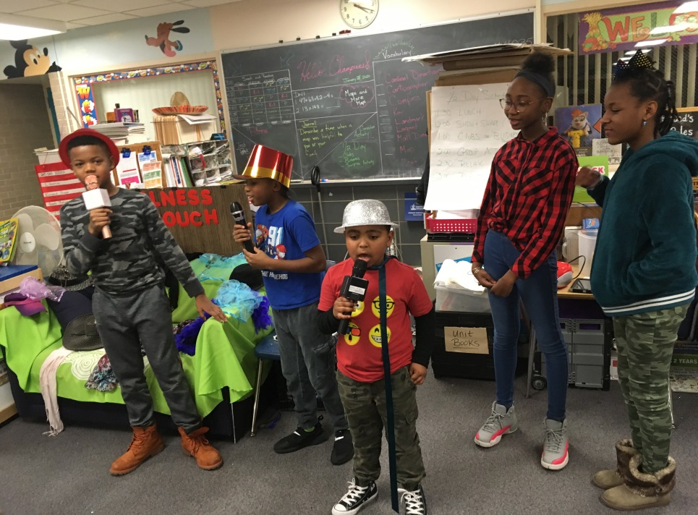

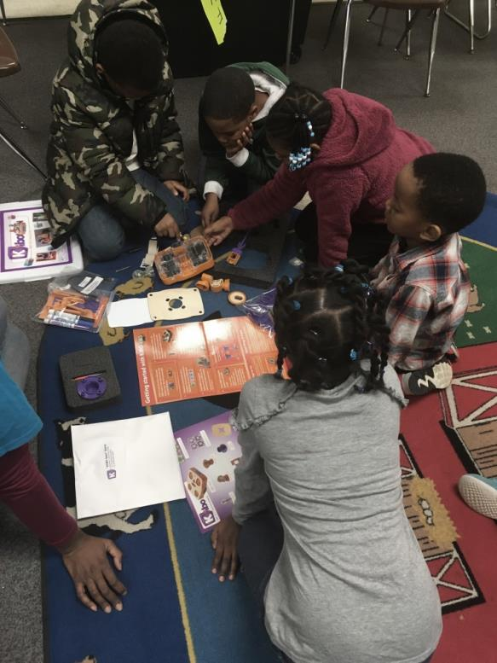



**PICTURES OF THE MONTH:**

**The students are really engaged in our new Technology Curriculum. Here one team is assembling a robot! In the second picture, the students dress up on the ½ day for our “Motown” event.**

**Rates:**

Registration Fee: $25.00 per family

After Care Session: $10.00

Before Care Session: $6.00

Re-enrollment fee: $20.00

Early Dismissal (1/2 Day) Additional $11.00 until 3:00 plus regular Aftercare session fee after 3:00.

Late pay fee: $10.00 per week. Tuition is due every Wednesday of each week.

Late pick up fee: 6:01-6:15pm $10.00; 6:16pm-6:30pm $20.00; 6:31pm-6:45pm $30.00; 6:46pm-7:00pm $40.00. per child.

**Break Programs: full day only option $34.00 per child per day.**

**Site Name: Stevenson Elementary**

**Site: #4035**

**Staff: Mrs. Rand- Southfield Field Coach, Director and 4th-5th Grade Teacher** [KRand@discoverchampions.com](mailto:KRand@discoverchampions.com)

**Mr. Morris- 2nd & 3rd Grade Teacher**

**Miss Scott- Kindergarten Teacher**

**Mrs. Stewart- 1st -2nd Grade Teacher**

**Miss Golden –Curriculum Teacher (a.m.)**

**Site Phone: 248.794.2071**

**Operating Hours:**

**6:30 a.m. - 8:00 a.m.**

**3:00 p.m. - 6:00 p.m.**