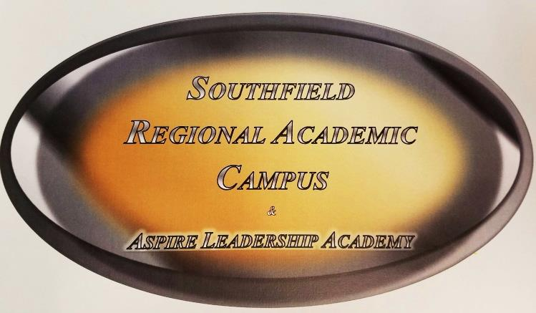
a
DWAYNE EASON - PRINCIPAL
COUNSELORS * SHERITA TATE * TALIAH WILLIAMS-HUNTER

21705 EVERGREEN ROAD, SOUTHFIELD, MI 48075
PHONE: 248-746-0012 FAX: 248-746-0028

Dear Southfield Regional and ASPIRE Families:
On behalf of the Southfield Regional and ASPIRE staff, this message is to update you on resources you may need during the three-week closure of school from Monday, March 16, 2020 through Friday, April 10, 2020. We want to briefly outline the resources available.
DIGITAL LEARNING: GOOGLE CLASSROOM
Online learning is not new to many of our students, parents and teachers. Many students are “experts” in accessing Google Classroom, submitting assignments and communicating with their teachers. While many of our teachers use this system every day, others do not, and we know there will be challenges to overcome as we transition all teaching and learning online. We ask you to please be patient, and know that your child’s teachers also will be extending that same patience. We also ask that you stress the importance with your child of completing their assignments each day, as we do not want their learning to be negatively impacted. More information about Google Classroom is online at https://www.youtube.com/watch?v=xfgqtCi7hdo
Digital Learning Days
Note: Students will utilize Digital Learning Days from Monday, March 16, 2020 through Friday, April 10, 2020.
Southfield Regional and ASPIRE plans to recover instructional time lost due to school closure by utilizing online learning using Google Classroom.
How will it work for students?
• Students will use the Google Classroom where they will access assignments, resources, and other materials.
• Students unable to complete the assignments online will have an opportunity to pick up a hard copy Wednesday, March 18th from 9 a.m. – 12 p.m. Students in Mr. Bloomhuff’s classroom will need to use the classroom book to complete all assignments.
• Student work will be expected to be turned in to the teacher digitally.
• Google classroom information can be retrieved from the school’s website https://www.southfieldk12.org/schools/hs/southfield-regional-academic-campus/
Note: Please understand, we do not expect nor do we want your child to be tied to their device for six hours a day. We anticipate the assignments and projects provided will take approximately three hours daily. It may take some students longer and that’s fine.
We believe there should be a balance between online learning and other educational opportunities like reading, writing, practicing the skills they have learned and collaborating with peers. Equally important is making sure your child’s mental health needs are met; this includes time to play, relax and spend time with family.
Students should use their school email address (username@southfieldk12.org) and password if they need to email administration for assistance. If your child is having trouble logging in, please email me and I will submit a help desk ticket for password reset.
The link below has information for free internet service for 60 days. This is for qualifying applicants only.
https://www.wxyz.com/news/national/coronavirus/comcast-offering-internet-essentials-package-free-for-60-months-during-coronavirus-outbreak

Community Food and Pantries

Southfield Public Schools will be offering up to two meals per day to all children ages 18 and under for free. This includes students with disabilities ages 18-26 with an active individual education program (IEP).

We will continue to work with all of our partners to provide the necessary support to our students, staff, families and the community at large.

Finally, thank you for your support and patience as we navigate this unique time in our world together. The Southfield Regional and ASPIRE team is happy to answer your questions and address your concerns.

Dwayne Eason

