PRESS RELEASE

Submitted By: BPA-SA&T Advisors
Cheryl Dunn (cheryl.dunn@southfieldk12.org)
Wendelin Williams (wendelin.williams@southfieldk12.org)

For Immediate Release

January 13, 2020

Business Professionals of America - Southfield A&T Chapter
Regional Conference Winners
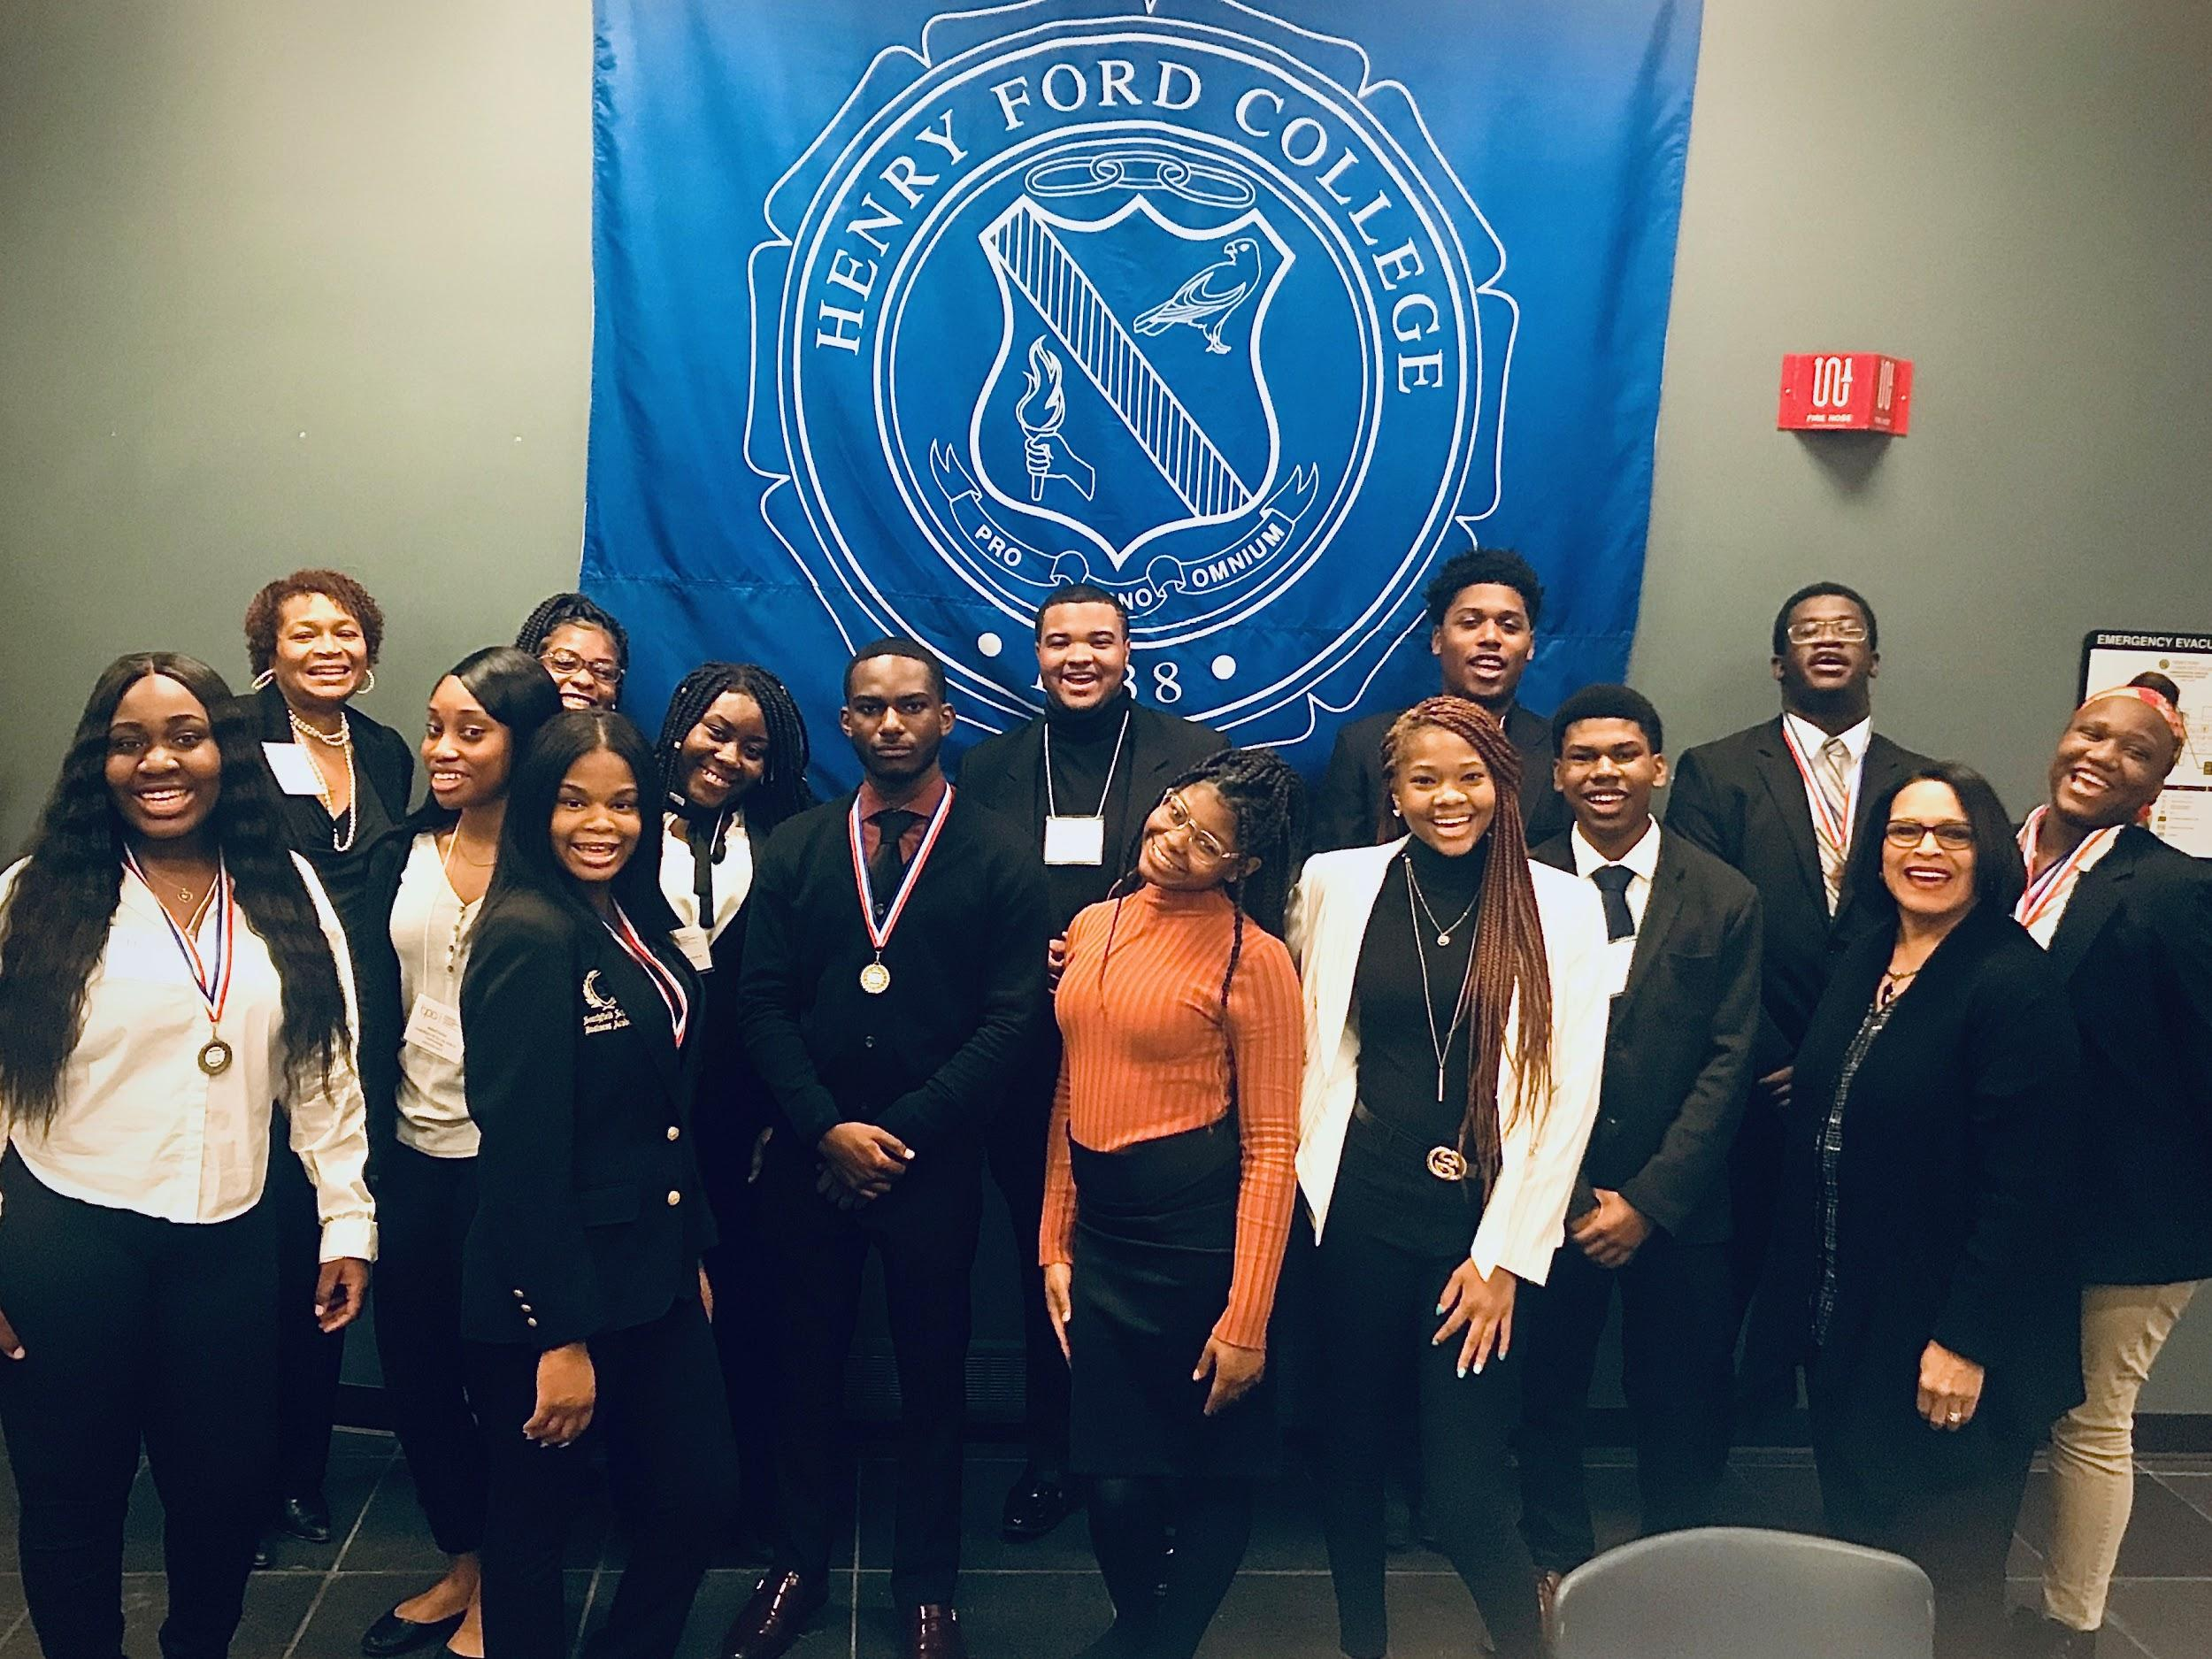

Members of the Business Professionals of America (BPA) - Southfield A&T Chapter participated in Regional Competitions held at Henry Ford Community College in Dearborn, MI on Friday, January 10th. The SA&T Chapter came out on top in several events as part of the BPA Workplace Skills Assessment Program. Skills that students learn through participating in a variety of business experiences are beneficial and will help prepare them for various careers in the workforce. This was evident as they excelled in the following events:

- Individual Events:
  - Oluwadarasimi Olorunsola - 1st Place, Interview Skills
  - David Williams - 3rd Place, Computer Security
  - Nneka Dike - 4th Place, Advanced Interview Skills
  - Chantel Chambers - 4th Place, Fundamental Desktop Publishing
  - Ndudi Ilechie - 5th Place, Fundamental Desktop Publishing
  - David Williams - 5th Place Computer Network Technology
  - Nneka Dike & Patrick Ingram - Torch Award Recipients

- Team Events:
  - Broadcast News Production Team - 1st Place
    - Ah’Layjah Lockett
    - Stephanie Nwagwu
    - Shardiah Moss
  - Presentation Management Team - 2nd Place
    - Madison Armstrong
    - Lauryn Bradley
    - Kyla Kenney

~ Qualified to Attend State Leadership Conference ~
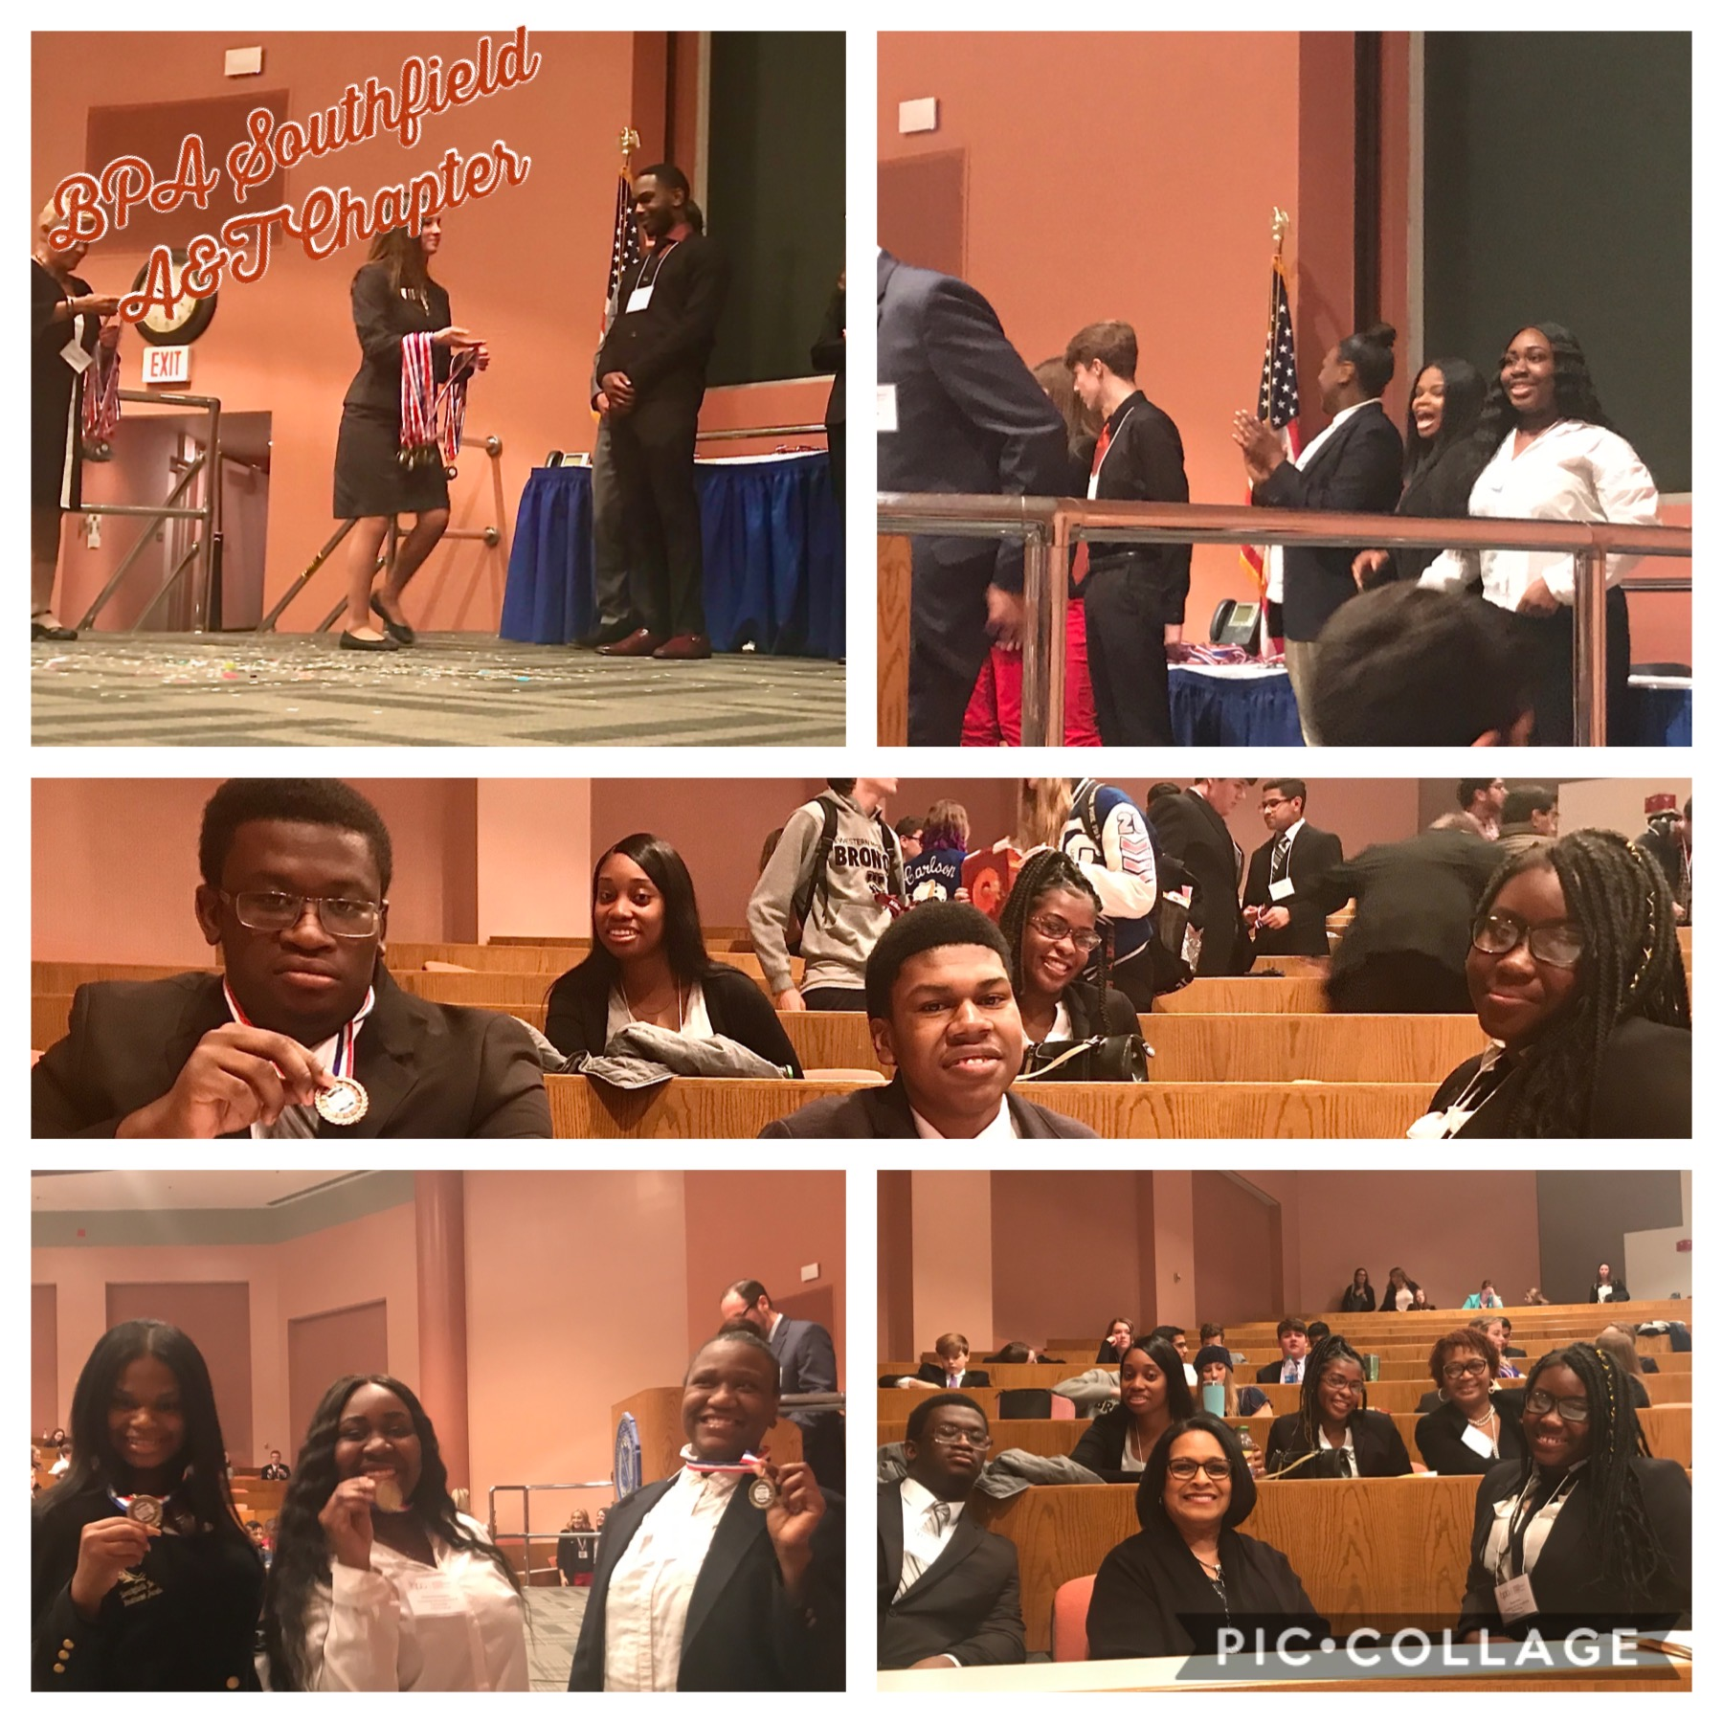
These students now qualify to attend the State Leadership Conference, March 11th-15th, at the Amway Grand Hotel in Grand Rapids, MI. At this conference, students will participate in business-related events and compete for top honors once again. Eligible students will continue on to the National Leadership Conference in Washington, DC in the month of May.

Business Professionals of America is full of bright, young people wishing to enter a fulfilling, business professional career. This beneficial organization is helping our youth to have a brighter future.

# # #

