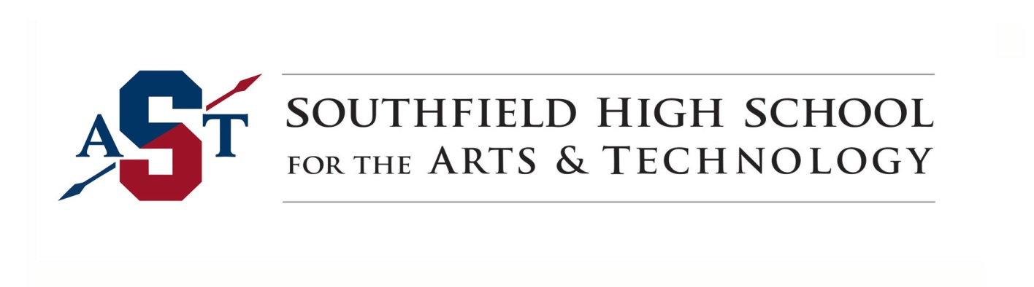Dear Parents & Students,
It is our goal to support our school community, family and friends during this pandemic. During the school closures, it is important for us to navigate these uncharted waters together. Therefore, we encourage you to please use our district and school websites for updates and to access additional resources for support. This is a time of rapidly changing information and we are committed to regular communication. We appreciate your continued attention to these emails. Please see the district website (www.southfieldk12.org/covid19).
Our staff is committed to providing continual learning for all students grades 9 – 12. Assignments will be accessible for students via Google Classroom. Google Classroom is a web-based system that can be accessed via a mobile phone, tablet, computer, or Chrome book. Daily, you can expect:
-Your child will log in to Google Classroom.
-Learning opportunities will be posted for your child.
PLEASE NOTE: If accessing Google Classroom via mobile phone, you can download the app, or access it using the following link: https://classroom.google.com. We are working diligently to make the transition to virtual learning as seamless as possible.

The codes for our teachers’ Google Classrooms are attached and listed on our school’s website, along with teachers’ office hours for direct support. All students are encouraged to continue reading books / articles of interest, in addition to utilizing the resources provided on Khan Academy in preparation for PSAT / SAT testing.

Regarding student meals, Southfield Public Schools will be offering up to two meals per day to all children ages 18 and under for free. This includes students with disabilities ages 18-26 with an active individual education program (IEP). Meals will be distributed at Thompson K-8 International Academy (16300 Lincoln Drive, Southfield 48076) starting Monday, March 16, 2020 (10 a.m. - 2 p.m.). The remainder of the week’s distribution will be 8 a.m. - 1 p.m.
We are also prepared to deliver food via SPS bus routes starting Tuesday. Full details are attached with bus routes and times. Please know that the Michigan Department of Education provided a waiver allowing us to feed any/all children in the community, regardless of their school district or economic status, seven days per week during this crisis.

We are working with all of our partners to provide the necessary support to our students, staff, families and the community at large.

We want to make people aware of some food pantries that can be shared with the community. Please help spread the word on community food pantries that anyone can have access to within our school community. We need to be there for our community through these tough times.

Church Of The Transfiguration:
Address: 25225 Code Rd, Southfield, MI 48033 - Across from Southfield High School for the Arts & Technology (10 mile).
Phone: (248) 356-8787
Monday - 9 am - 11:30 am
Wednesday - 9 am - 11:30 am

The Franciscan Outreach Program is open on Monday and Wednesdays, from 9:00 until 11:30. They welcome all families and would need to have a picture ID in order to register.

St. David's Episcopal Church Food Pantry:
St. David's runs a food pantry every Friday from 6 pm - 8 pm. Please help spread the word. This is open to everyone in our community and surrounding communities.

St. David's Episcopal Church
Address: 16200 W Twelve Mile Rd, Southfield, MI 48076 - Near Vandenberg Elementary School.
Phone: (248) 557-5430
Friday - 6 pm - 8 pm
St. David's will have a food pantry every Friday from 4 pm -6 pm.

Additional Resources:
United Way 211 is a free, confidential referral and information helpline and website that connects people of all ages and from all communities to essential health and human services they need, 24 hours a day, seven days a week.
https://www.unitedway.org/our-impact/featured-programs/2-1-1
Wi-Fi Information
https://www.detroitnews.com/story/news/nation/2020/03/14/us-providers-offering-free-wi-fi-days/111427484/

Thank you for your support. Wishing health and wellness to all!
Charity Jones
Ms. Charity Jones
Principal

