Drill Information  Date Time Type |  |  | Name of individual  in charge of drill | Principal’s signature
9-29-14 | 10:45am | Fire drill | Kimberly Beckwith | 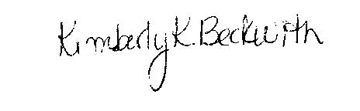
10-2-14 | 2:15pm | Lock down | Kimberly Beckwith
10-10-14 | 3:00pm | Fire drill | Kimberly Beckwith
3-16-15 | 2:15pm | Tornado drill | Kimberly Beckwith
3-31-15 | 2:20pm | Lock down | Kimberly Beckwith
4-15-15 | 10:15am | Fire Drill | Kimberly Beckwith
4-15-15 | 2:00pm | Tornado drill | Kimberly Beckwith
4-30-15 | 9:15am | Tornado Drill | Kimberly Beckwith
5-1-15 | 2:40pm | Fire drill | Kimberly Beckwith
2014-2015 School Drills McIntyre Elementary

