Teachers Name: Ms. Butler Subject: Visual Art Grade: K

Unit/Lesson Title: Optical Illusion Art/shapes, lines-curved, horizontal
Date(s): 6/1/20
Analyze Apply Compare/contrast Create Identify Interpret Observe Organize | Alignment to Common Core Framework  Math-lines: square, and pattern.
Element of Design  Line, shape, form, size, texture, color, value and space. | Principals of Design  Balance Movement Contrast Rhythm Pattern Unity Emphasis
KUD
Know:
An optical illusion of two reversible figures and a vase. Can you see both? This picture is a great example of an optical illusion. An optical illusion is a visual stimuli that is perceived by the eyes and then comprehended by the brain in a way that is different from reality.

Understanding:
How to create an optical illusion card.

Do: Art Production: What will our students be able to do?
- Optical Illusion Flip Card (rabbit/duck)

Cross curriculum: Math- lines, shapes and patterns
Content Standard(s):
Standard 5-Recognize, analyze, and describe connections among
the arts; between the arts and other disciplines; between the arts and everyday life. Standard 1-apply skills and knowledge to perform in the arts.
Standard 3-analyze describe and evaluate works of art.
Standard 2- apply skills and knowledge to create in arts.
Essential Question(s):
- What does a rabbit look like?
- What does a duck look like?
Vocabulary- Optical Illusion, rabbit, duck, curved line, and horizontal line
Instructions are guided lessons
(student follows along at his/her own pace drawing project)
Day 1
- View You tube video- “Duck! Rabbit Read Outloud story for kids”, subscribe- Store time for family
- Complete handout ---- What is your Opinion, Duck or Rabbit?
- What do you see?
(2) Why do you think you see a duck or rabbit?
Refer to “Point of View” handout

Day 2-3
- Color duck handout, and cut it out
- Color rabbit handout and cut it out
- Glue handouts together (back to back), insert the regular black pencil in the center to support the papers.
- View You tube video- “Create Optical Illusion, subscriber KCEdventure
(example of sandwich papers together using a pencil in the center only)

Materials needed; colored pencils, crayons, Duck drawing (handout or draw it on white paper), Regular pencil (sandwich the rabbit and duck paper together with the pencil in between the papers using glue), Rabbit drawing (handout or draw it on white paper), regular black pencil, eraser, scissors, & glue.

Day 4
- Art Crawl---Show your project to friends/family/classmates also on flipgrid.
- Student/artist complete 123 art ticket.
- Pick someone to complete the art critique about your art piece.
- Submit your artwork, art ticket and art critique to me via
- april.butler@southfieldk12.org,
- Flip grade
- google classroom (review student lessons, announcements)
Extended Learning;
Trace your hand, draw horizontal lines outside of the hand, and draw curved lines inside the hand connecting to the horizontal lines.
Refer to You Tube video- Op Art Hand Tutorial, subscriber- Emily Finan
Lesson Accommodations (Special needs and gifted)
Step by step procedure, extended time.

What will you do if students do not understand?
Complete components (smaller) in the five days instead of two days.

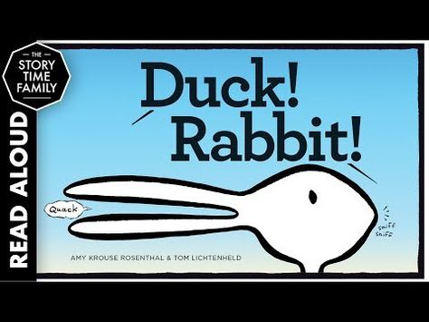

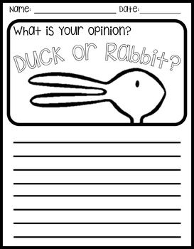

Point of View example
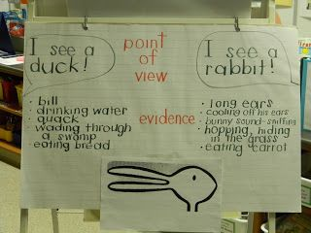

Rabbit and Duck Example
(color and patterns, sandwich pencil between the duck and rabbit using glue)

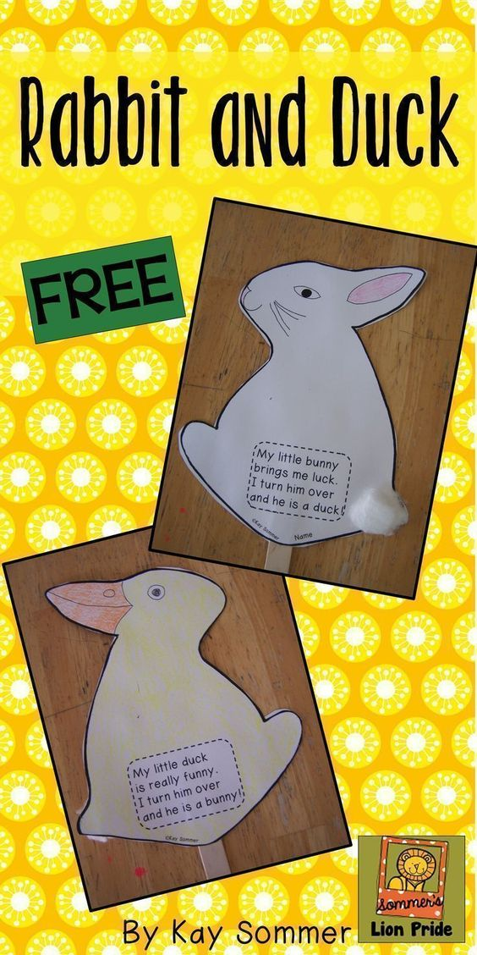

Duck Template
(Color duck)

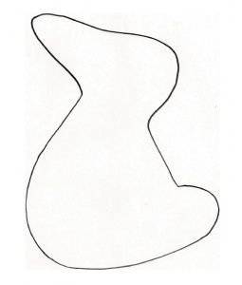

Rabbit Template
(Flip rabbit over in the opposite direction, then color)
