Teachers Name: Ms. Butler Subject: Visual Art Grade: 1st

Unit/Lesson Title: Optical Illusion, lines and patterns
Date(s): 6/1/20
Analyze Apply Compare/contrast Create Identify Interpret Observe Organize | Alignment to Common Core Framework  Math-lines: square, and pattern.
Element of Design  Line, shape, form, size, texture, color, value and space. | Principals of Design  Balance Movement Contrast Rhythm Pattern Unity Emphasis
KUD
Know:
An optical illusion of two reversible figures and a vase. Can you see both? This picture is a great example of an optical illusion. An optical illusion is a visual stimuli that is perceived by the eyes and then comprehended by the brain in a way that is different from reality.

Understanding:
How to create an optical illusion hand.

Do: Art Production: What will our students be able to do?
- Optical Illusion hand

Cross curriculum: Math- lines, shapes and patterns
Content Standard(s):
Standard 5-Recognize, analyze, and describe connections among
the arts; between the arts and other disciplines; between the arts and everyday life. Standard 1-apply skills and knowledge to perform in the arts.
Standard 3-analyze describe and evaluate works of art.
Standard 2- apply skills and knowledge to create in arts.
Essential Question(s):
(1) What is optical illusion?
Vocabulary- Optical Illusion, repeat, Horizontal line, curved line.
Instructions are guided lessons
(student follows along at his/her own pace drawing project)
Day 1-2
- View You tube video- “Duck! Rabbit Read Outloud story for kids”, subscribe- Store time for family
- Complete handout ---- What is your Opinion, Duck or Rabbit?
- What do you see?
(2) Why do you think you see a duck or rabbit?
Refer to “Point of View” handout

Day 2-3 -Select video 1 or 2 art project to complete.
- View You tube video- “Op Art Hand Tutorial, subscriber Emily Finan
Create project (guided lesson) following along
Hand tutorial Instructions: Have students trace their hand with outstretched fingers in pencil on their paper. It does not need to be in the middle, but that is easiest.
Use rulers to create 1” stripes horizontally across the paper. Demonstrate how to make these even. Skip over the hand area without drawing in it.
Next, show how to gently curve lines to connect over the hand creating a “bulge.”
Trace all lines in black marker. (A water-based black marker will bleed as you use more colors and look smudgy.)
Have students pick two colors that are either both hot (red, orange, yellow, peach, pink) or both cold (blue, green, turquoise, purple, violet) and color in the stripes NOT including the hand shape, alternating colors.
Then be sure to alternate colors opposite on the hand, as pictured in the example. Happy Optics!
- View You tube video-Let’s Make an Optical Illusion Heart, subscriber Cassie Stephens
Materials needed; regular black pencil, colored pencils, crayons, markers, white paper, & eraser.

Day 4
- Art Crawl---Show your project to friends/family/classmates also on flipgrid.
- Student/artist complete 123 art ticket.
- Pick someone to complete the art critique about your art piece.
- Submit your artwork, art ticket and art critique to me via
- april.butler@southfieldk12.org,
- Flip grade
- google classroom (review student lessons, announcements)
Extended Learning;
Draw the project you didn’t complete Hand or heart.
Lesson Accommodations (Special needs and gifted)
Step by step procedure, extended time.

What will you do if students do not understand?
Complete components (smaller) in the five days instead of two days.

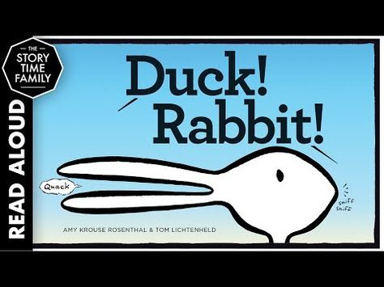
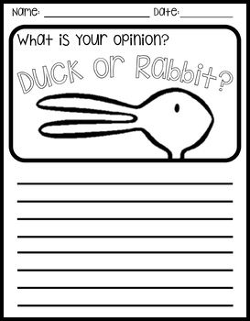

Point of View example
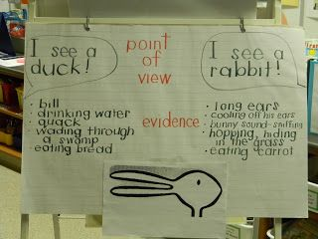

Hand Optical Illusion

