ADLER ELEMENTARY GRADES 4th/5th ROOM 14

On Time! On Task! On A Mission!

Name __________________ **HR** _____

MCj04247380000[1]Babridge Briefs

March 13-April 3, 2020

Volume 1, Issue 12

## CLASSROOM NEWS…Home-Learning! ☺



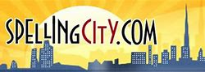

Spelling & Definition Tests 4th/5th Grades

Words have been uploaded for each grade. There will be only 1 list for each grade.

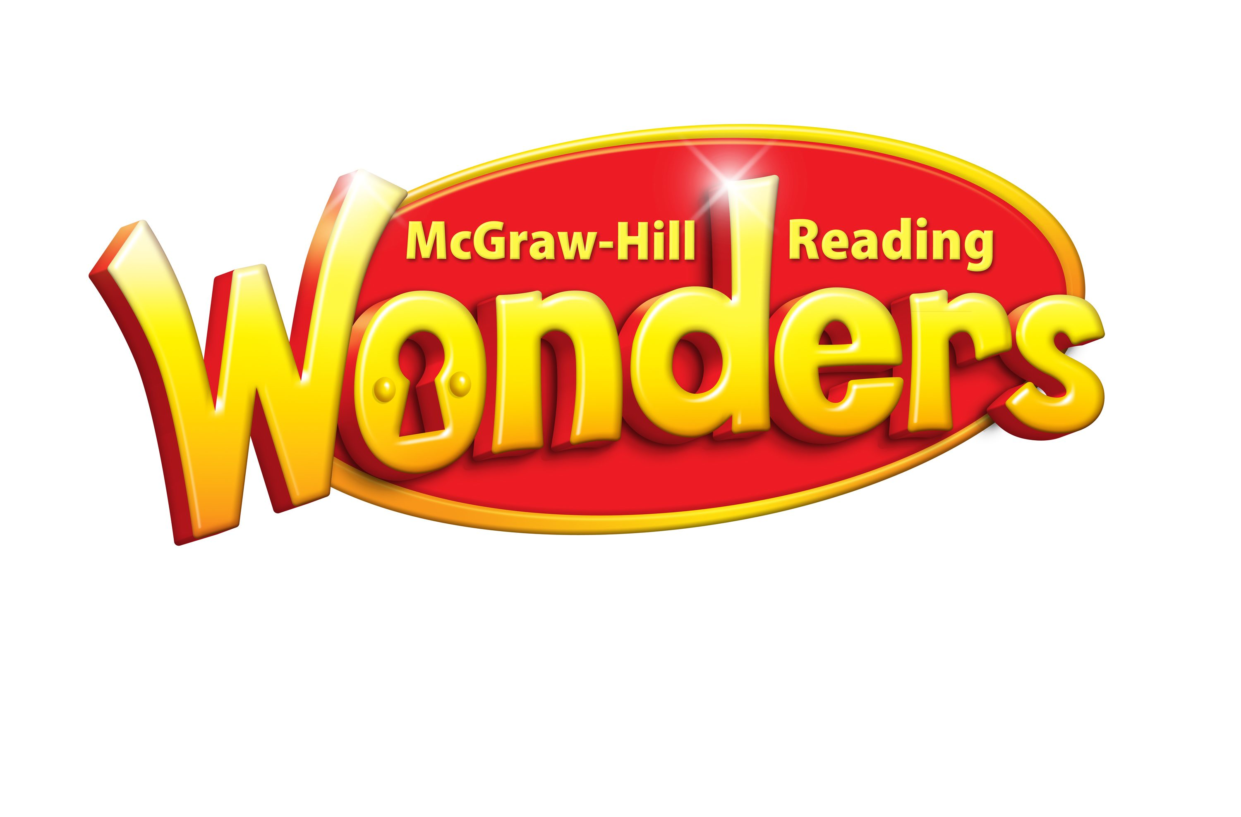

Assignments have been given for the following stories:

5th ☞ One Well

4th ☞Abe’s Honest Words: The Life of Abraham Lincoln

Greetings Parents!

School is out for the following 3 weeks, (or 4 if you count Spring Break).

So, students will be given online learning work that can be done at home.



This is how we’re going to be communicating (for the most part) during the next few weeks.



Spend this time reading, working and reviewing ELA skills as if I was standing right next to you.



Do your best!

## Homework…Online Learning

**Reading: Complete**-(Alsobrooks, Babridge, Haugen, Seremet )

🕮WONDERS: Read the following stories, then, complete the uploaded assignments on Wonders.

4th🖎 Abe’s Honest Words: The Life of Abraham Lincoln 5th🖎 One Well

**Writing/English: Complete-** (Alsobrooks, Babridge, Haugen, Seremet)

Study your spelling words and definitions (test when we get back). Practice writing a sentence for your spelling words on SpellingCity. This will help you when we write in class.

4th🖎 Lesson Abe’s Honest Words…

5th🖎Lesson One Well

#### Mrs. Babridge’s Homeroom Class (5-2)

Special Subjects Schedule 2nd Card Marking

Monday Tuesday Wednesday

Art Gym Music

Thursday Friday

Art Gym

Have a GREAT week!

Mrs. Babridge

simone.babridge@southfieldk12.org

[](http://www.bing.com/images/search?q=beagle&view=detail&id=579D2ACAAC14656893651A1B44E1B3E214CA38F3&first=120&qpvt=beagle&FORM=IDFRIR)

S. Babridge

MORRIS ADLER ELEMENTARY Lesson Plans 5th/4th Grades ELA

|  |  |  |
| --- | --- | --- |
| Day | Tasks: March 16th - April 13th (Weeks 1-3) 5th Grade |  |
| Monday | One Well, 1st read/listen…Review Key Vocab, begin studying spelling words, complete spelling work (on SpellingCity); compete Key vocabulary word practice |  |
| Tuesday | Watch learning link @Author’s Point of View, complete online graphic organizer; then, work on the expository; Online skills learning-(WONDERS) Suffixes: phonics practice |  |
| Wednesday | One Well 2nd read/listen; review key vocabulary; Complete Genre/ Text Feature, pg.186 |  |
| Thursday | One Well-Read/Listen, complete online vocabulary pg. 81  Read/complete (The Wonders of Water) pgs. 183-185 |  |
| Friday | Study spelling words and definitions (SpellingCity) |  |

|  |  |  |
| --- | --- | --- |
| Day | Tasks: March 16th - April 13th (Weeks 1-3) 4th Grade |  |
| Monday | Abe’s Honest Words, 1st read/listen…Review Key Vocab, begin studying spelling words, complete spelling work (on SpellingCity); compete Key vocabulary word practice |  |
| Tuesday | Watch learning link @Author’s Point of View, complete online graphic organizer; then, work on ; Online skills learning-(WONDERS) Grammar activity: linking verbs; complete-plurals: phonics practice |  |
| Wednesday | One Well 2nd read/listen; review key vocabulary; Complete Genre/ Text Feature (biographies)-WONDERS online |  |
| Thursday | One Well-Read/Listen, complete online vocabulary pg. 81  Read/complete (Words for Change) |  |
| Friday | Study spelling words and definitions (SpellingCity) |  |