Dear 4th Graders,
I hope that you enjoy completing the activities that I have created for you. Choose at least 10 activities to do from your Bingo board. In addition to these activities, please complete weekly tasks: Week 1: 6/1-6/5,daily choose a different website highlighted in red each day to practice your math facts. Week 2: 6/8-6/12, daily choose a different website highlighted in green to play various math games. *See the back page
B | I | N | G | O
Use the Break Apart Multiplication Strategy to solve each problem.  423 x 3 =  67 x 5 =  618 x 9 =  48 x 6 = | Find the quotient for each problem.  64/8 =  25/5 =  28/7 =  54/6 = | Solve problems using Order of Operations.  (P),E, M, D, A, S  A. 7 + 5 + (9 x 8) =  B. 33 – 17 – (4 x 3) =  C. (12 x 12) + 7 x 5 = | Word Problem Practice  Joshua and Brian like to play one-on-one basketball together. Joshua scored 29 points on Thursday. The total number of points scored on Thursday was 56. How many points did Brian score? | Play addition and subtraction war using a deck of cards (2 players). Deal the cards to each player. Each player turns card over at same time. The person that adds or subtracts the numbers the fastest keeps the cards. The winner is the player that has the most cards.
Subtract with regrouping. Use Place Value Block drawing Strategy.  71 – 23 =  95 – 48 =  86 -59 =  43 - 17= | Word Problem Practice  Chasity ate one hotdog each day for four day straight. She puts seven squirts of ketchup on each hotdog. How many squirts of ketchup did she use altogether? | Use the Break Apart Multiplication Strategy to solve each problem.  24 x 4 =  15 x 7 =  73 x 9 =  36 x 8 = | Solve problems using Order of Operations.  (P),E, M, D, A, S  A. (8 x 7) – 6 x 3 =  B. 9 + 7 + (9 x 7) =  C. 54/6 – 3 x 2= | Find the quotient for each problem.  16/2 =  56/8 =  36/4=  144/12 =
Play multiplication war using a deck of cards  (2 players).  (Same rules as addition and subtraction war) | Solve problems using Order of Operations.  (P),E, M, D, A, S  A. 12/2 + 28/7 =  B. (85-36) + 8 x 4 =  C. 63/7 + (11 x 11)= | 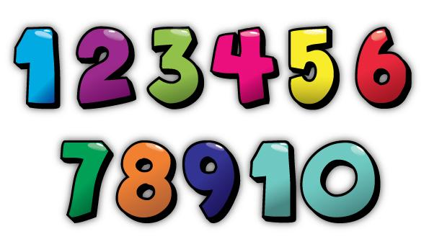 | Word Problem Practice  Bobby watches too much television. One day he watched from 8:00 a.m. to 3 p.m. How many hours of television did Bobby watch that day? | Use the Break Apart Multiplication Strategy to solve each problem.  9 x 9 =  135 x 3 =  9 x 7 =  422 x 4 =
Word Problem Practice  Jaydn’s cocoa is 142 degrees Fahrenheit. Now the cocoa is 103 degrees Fahrenheit. How many degrees did the cocoa cool? | Use the Break Apart Multiplication Strategy to solve each problem.  56 x 8 =  41 x 6 =  734 x 4 =  417 x 2 = | Find the quotient for each problem.  33/7=  78/9 =  18/5=  47/6 = | Subtract with regrouping. Use Place Value Block drawing Strategy.  221 – 25 =  752 – 477 =  312 -76 =  543 – 64 = | Solve problems using Order of Operations.  (P),E, M, D, A, S  A. 30/6 + 84 - 17 =  B. 48 + (8 x 8) =  C. 135 – 48/6 =

Math Websites

- http://www.sheppardsoftware.com/math.htm
- http://mathgametime.com/
- https://www.funbrain.com/math-zone
- http://toytheater.com/category/math-games/
- https://www.hoodamath.com/games/third-grade.html
- https://www.hoodamath.com/games/fourth-grade.html
- https://www.hoodamath.com/games/mathtimedtests.html
- https://www.mathsisfun.com/timestable.html
- https://www.factmonster.com/math/flashcards

