B | I | N | G | O
Play addition and subtraction war using a deck of cards (2 players). Deal the cards to each player. Each player turns card over at same time. The person that adds or subtracts the numbers the fastest keeps the cards. The winner is the player that has the most cards. | Round to the nearest hundred.  455 –  201 –  616 –  736 – | Math Riddle  If you are out of school for four weeks, how many school days does that equal? | Write the following numbers in expanded form:  548 –  62 –  129 – | Draw as many shapes as you can find wherever you are right now.  Example: a circle “clock”  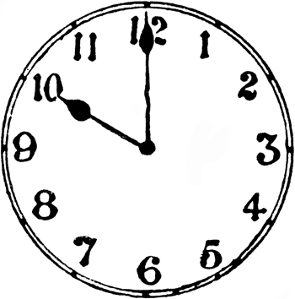
Draw Base Ten blocks for each of the numbers:  15  52  35  443 | Write the missing numbers to complete the pattern.  22, 24, , 28, , 30  76, , 88, , 100 | Create your own number chart or number line from 1 to 100. | Start at the number 0 and count by 2’s, 5’s, and 10’s to the highest number that you can. | Create a bar graph that shows how many jumping jacks you were able to do for week 1, week 2, and week 3.
Complete the table.  Subtract 10  20  57  32  76 | Create your own multiplication or division story problem.  Have a family member solve your problem. | 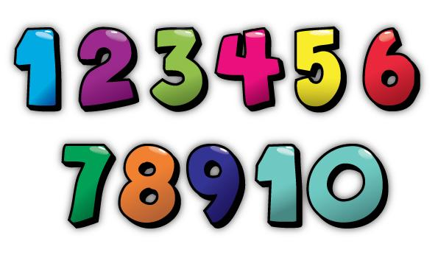 | Math Riddle  Your swim practice begins at 7: 15 a.m. It lasts for 50 minutes. What time will practice end? | List as many addition double and turn around facts as you can.  Example:  2+2=4 (Double fact)  3+2 =5 and 2+3= 5 (Turnaround fact)
Solve problems using Order of Operations.  (P),E, M, D, A, S  A. (20 + 2) + 3 =  B. 5 + 6 x 4 =  C. 11- 4 x 6 = | Play Number “Top It”. (2-4 players)  Each player pulls a card from the deck. The player with the largest number keeps the cards. Player with most cards at the end of the game wins. | Complete the table.  Add 10  6  9  12  18 | Math Riddle  What is the name of a shape that has 3 sides and 1 right angle? | Play multiplication war using a deck of cards  (2 players).  (Same rules as addition and subtraction war)
Create your own multiplication chart. | Math Riddle  A grandfather, 2 fathers, and 2 sons went to the movies. Everyone bought one ticket each. How many tickets did they buy all together? | Round to the nearest ten.  76-  23-  67-  81- | Use a menu from a restaurant and list as many food items as you can that totals no more than $20. | Create your own addition or subtraction story problem.  Have a family member solve your problem.
Dear Morris Adler Student,

We hope that you enjoy completing the activities that we have created for you. Choose at least 15 activities to do from your Bingo board. In addition to these activities, please complete weekly tasks: Week: 3/16-3/19, choose a different website each day to practice your math skills. Week 2: 3/23-3/27, complete as many tasks on the Bingo chart as you can. Week 3: 3/30-4/3 practice your math facts daily. See you soon, Your Morris Adler Teachers (Math Websites on the back)
Math Websites

- Sheppardsoftware.com
- AAAmath.com
- Khanacademy.com
- Multiplication.com
- Coolmath.com

