Teachers Name: Ms. Butler Subject: Visual Art Grade: _2nd & 3rd

Unit/Lesson Title: Jacob Lawrence- Harlem Renaissance/shapes, lines and patterns
Date(s): 5/11/20
Analyze Apply Compare/contrast Create Identify Interpret Observe Organ7ize | Alignment to Common Core Framework  Math-lines: curved line, and square.
Element of Design  Line, shape, form, size, texture, color, value and space. | Principals of Design  Balance Movement Contrast Rhythm Pattern Unity Emphasis
KUD
Know:
- Jacob Lawrence was an African American painter known for representation of
African - American life.
- Paper craft are made out of any cardboard, construction paper, copying paper.
Understanding:
- What stories Jacob Lawrence created in his art.
- Which type of business/living spaces are needed to create a neighborhood.
- How to create 3d buildings out of paper.
D Do: Art Production: What will our students be able to do?
- Create a depiction of your neighborhood using paper (cardboard, construction paper)
Cross curriculum: Math- lines, shapes, overlap and patterns
Content Standard(s):
Standard 5-Recognize, analyze, and describe connections among
the arts; between the arts and other disciplines; between the arts and everyday life. Standard 1-apply skills and knowledge to perform in the arts.
Standard 3-analyze describe and evaluate works of art.
Standard 2- apply skills and knowledge to create in arts.
Essential Question(s):
- What kind of stories did Jacob Lawrence create?
- Who is Jacob Lawrence?
- Describe a neighborhood?
- Where did Jacob become interested in art?
- What is the “black migration” series about?

Vocabulary-Jacob Lawrence, organic shapes, cardboard box, BLACK MIGRATION, patterns, storyteller and collage.
Day 1

View You tube video - “Jacob Lawrence”, By Art on the iPad
(2) Answer questions while viewing video
(a) What kind of stories did Jacob Lawrence create?
(b)Who is Jacob Lawrence?
- Describe a neighborhood?
- Where did Jacob become interested in art?

What painting series was the most popular?

(3) Questions can be answered orally or written.

Day 2
Create your neighborhood by selecting the following---construction paper (#2), copying paper (#4) or cardboard (#3).
- View You tube video - Sesame Street – Places in Our Neighborhood
- View You Tube video - Paper building & city making for school project work-easy craft.
- View You Tube video- “How to make a small cardboard house”
- View You Tube video - “How to make a Paper House - very easy- Paper Craft” by Easy craft.
- Create your neighborhood using various sizes of buildings. Color your project using crayons, paint, markers. Label each building (home, grocery, restaurant, gas station etc.) Your neighborhood should have at least 4 buildings (including your home).

Materials needed: scissors, glue, crayons, copying paper, cardboard, construction paper/colored paper, pencil, eraser, white drawing paper, markers.

Day 3
- Art Crawl---Show your project to friends/family/classmates also on flipgrid, while telling them about your art work.
- Student/artist complete 123 art ticket.
- Pick someone to complete the art critique about your art piece.
- Submit your artwork, art ticket and art critique to me via
- april.butler@southfieldk12.org,
- https://flipgrid.com/butler8450
- google classroom codes (Refer to Adler website-Visual Art)

Extended Learning; Make 4 additional business in your neighborhood.
Lesson Accommodations (Special needs and gifted)
Step by step procedure, extended time.

What will you do if students do not understand?
Review project with a peer partner. Complete components (smaller) in the five days instead of two days.

Jacob Lawrence, Painter
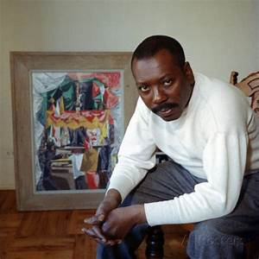

Jacob Lawrence Art

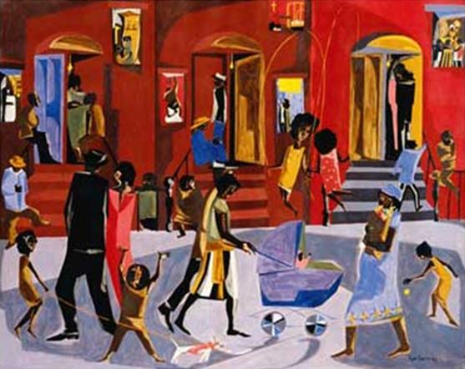
Pablo Picasso Face template

