April 8, 2021

Welcome Back!
Southfield Public Schools has licensed the Frontline Health Portal to provide you with convenient, 24-hour online access to items in your child’s health record. Using a secure username and password, you can view district-designated health information, communicate with our health & wellness staff, review/sign forms, and even provide the district with new information from outside health services received by your child.
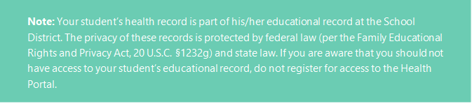

ACCOUNT ACTIVATION
Families can activate their account via our Mobile or Desktop application. (*Note, you do not need to register separately to gain access to both options.)
- For Mobile, please go to the Apple App Store or Android Apps on Google Play, search for Frontline Health Portal, and download the app.
- As a Desktop user:
https://app.HealthOfficePortal.com/SHM_Southfield_Public_School_District/Portal/Login.aspx

You will need to activate your account as a family with your personal email provided to the school district during your student registration with the district. (*If both parents/guardians provided their emails to the school district, you may use one of the emails to start one account or both emails to start more than one account.)

Complete the following steps to continue your activation:

Health Portal Login Screen
Select “Activate Account” located below the Log In box.
STEP 1: Temporary Password (Activate your account)
- Enter your primary email you provided to the District. Select the blue button “Send me a temporary password.” You will see a green checkmark and confirmation message, indicating the application sent your temporary password in an email with the Subject: “Your temporary password for Frontline Health Portal.” (Please check your email’s spam folder if you have not received the email in 10-15 minutes.)
- Within the password email, there is a temporary password and link to finish activating your account. Copy the temporary password or refer to it. Click on this link to go back to the Health Portal Login. Enter your Username (the personal email address you provided by the school district) and the temporary password.
STEP 2: Update Password
- After you select the Log in button, you update your password, following the password change process.
STEP 3: Terms of Use
- After you update your password, you will continue to the Portal Terms of Use. Click the checkbox beside “I have read and agree to the Terms of Use and Electronic Service Agreement” and follow the eSignature instructions. (Be sure to leave out any space(s) between /S/ and your name.)
- Select the “Confirm my agreement” button to complete the step.
STEP 4: A green checkmark and a message will provide agreement confirmation.
Click on “FAMILIES: Continue to Assign Students”
The application will prompt you to assign student(s) to your account. You will need to provide the following information for each child:
- Student Last Name
- Student School ID (as designated by the District)
- Student Date of Birth
To register additional children, remain on this step and provide the child’s information and click on “Add this student,” and continue this step until all your children are registered. Then select “I’m done adding students” to complete account activation.
STEP 5: Account Activated
- Select “Take me to Frontline Health Portal” to open the Health Portal.

HEALTH SCREENING FORM

Students/families will have an opportunity to complete their daily health screening form using the below link:

https://app.HealthOfficePortal.com/SHM_Southfield_Public_School_District/Portal/Login.aspx

STEP 1: Enter your email address, password and press Log
For families, this will be the personal email address provided to the District.

STEP 2: This will take to the Home Page.

STEP 3: Look for your “To Do List” under the Portal User Information section.

STEP 4: Under the Event Column, please click on the “Questionnaire Form” icon.

STEP 5: The daily health screening form will appear on your screen. Please answer the questions honestly and select “Yes” at the bottom of the screen.

STEP 6: You will receive approval to come into the District or instructions on your next steps.

STEP 7: Click Sign Out to logout of the application.

