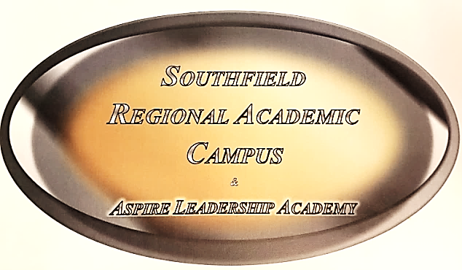

P.T.S.A. MEMBERSHIP REGISTRATION
The staff and students at Southfield Regional Academic Campus NEED YOU!! Please be a part of our
Parent Teacher Student Association!
The goal of P.T.S.A. is to assist the staff at the Southfield Regional Academic Campus to support and encourage student achievement!
Dear Southfield Regional Academic Parents,
We look forward to working together to make it a GREAT school year for our students!!
Please join the SOUTHFIELD REGIONAL ACADEMIC CAMPUS P.T.S.A. TODAY!!
WE WELCOME AND APPRECIATE YOUR SUPPORT!
YOU CAN MAKE A DIFFERENCE IN YOUR CHILD’S EDUCATION!!!
Please complete and submit this registration form along with the $10.00 membership fee per family.
Parent (s) Name: ____________________________________________________________Amount____________________
Home Address: ___________________________________________________________________________________________
Email Address: ___________________________________Student email: _______________________________________
Home Telephone: _________________________________Alternate Telephone: ______________________________
Student’s Name: _________________________________________________Student’s Grade: _____________________
Studies show that students perform better in school when a parent or guardian is involved. High school is a transitional time; your student is on their way to adulthood and will be making big decisions. Be an active part of their experience. Don’t worry if you don’t have a lot of time, your student, your school, and your community, appreciates any time you can give.

