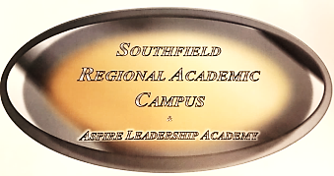
Southfield Public Schools
Southfield Regional Academic Campus
Bus Safety Rules
2018-2019

Dear Parents and Students:
Administration and the bus drivers met to develop guidelines on bus safety. Please review these guidelines together. The guidelines have been designed with students’ safety in mind. Students are responsible for knowing and following the bus rules.
- Students should be at designated bus stop at least 10 minutes prior to scheduled pick up time. Transportation appreciates your patience as due to traffic and weather conditions as occasionally schedules may run behind by as much as 15 minutes. Also, the first week of school routes may be adjusted and slightly changed. Your student will be notified should their pick or drop off times are changed.

- The bus driver is in charge and responsible. Follow directions the first time they are given.

- Show good manners!

- Ask the bus driver before opening windows. Keep hands, feet, head, objects, etc. inside the bus at all times.

- Eating or drinking on the bus is prohibited.

- Tobacco, drugs, alcohols or dangerous items will not be allowed at any time.

- Respect school property! Writing on, cutting, or damaging the bus in any way costs a lot of money and can be a safety hazard. Violators will be disciplined and responsible for the repair cost.

- Stay seated until the bus driver arrives at your stop. Face the front of the bus and keep hands, feet and objects to yourself. Keep the aisle clear!

- Animals, bugs, fish, and glass containers, etc. can create havoc and may not ride on the bus. If they are a part of a science project, a parent must deliver these items to and from school.

- Be safe at the bus stop. Arrive five minutes before bus scheduled pick up time. Do not run after a moving bus. Stand back from the roadway in a single-file line while waiting to board the bus at home and at school. Show respect for others while waiting.

- Parents/Guardians must notify the school before taking students off the bus at undesignated stops.

- Failure to adhere to our Bus Safety Rules will result in temporary or permanent removal from the bus.
THANK YOU FOR HELPING TO KEEP OUR STUDENTS SAFE!!
Your signature on Southfield Regional’s Document Acknowledgement Receipt Form will indicate your receipt of the Bus Safety Rules.

