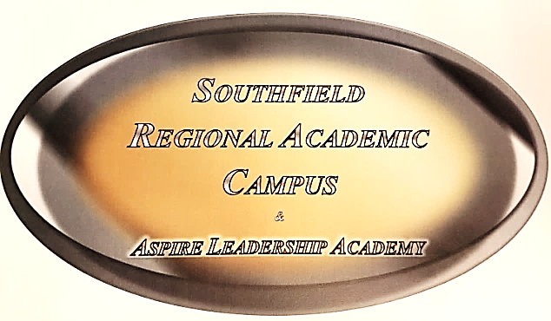

School Covenant of Participation
2018 – 2019
The Student Agrees To:
- Arrive on time and attend 100% of the time unless absent with an excused and appropriate reason.
- Complete and submit all assignments, class work, and homework on time.
- Adhere to the Southfield Public Schools Code of Conduct and the rules and regulations described in the Student Parent Information Packet.
- Refrain from being involved in self-defeating behavior.
- Refrain from the use of tobacco, drugs, and alcohol.
- Actively participate in school learning and activities to the best of his/her ability.
Southfield Regional Academic Campus Agrees To:
- Provide a safe, orderly, clean, and comfortable school/learning environment.
- Provide professional development for staff to ensure quality instruction.
- Provide an organizational structure that will allow parents/guardians and community to participate in school and gain information on student development and achievement.
- Emphasize increasing standardized test scores in area of mathematics, science, reading, writing, communication, and social studies.
- Post organizational meetings, date of Parent/Teacher Conferences and other activities and events related to parental participation and involvement.
The Parent/Guardian Agrees To:
- Ensure that the student arrives on time and attends school 100% of the time unless absent with an excused and appropriate reason.
- Assist in or monitor activities related to school and home assignments.
- Attend PTSA meetings, Parent/Teacher Conferences and other school activities and events.
- Be familiar with the school and be informed of school rules, regulations, and policies.

Your signature on Southfield Regional’s Document Acknowledgement Receipt Form will indicate your receipt of the School Covenant of Participation.
Southfield Regional Academic Campus

