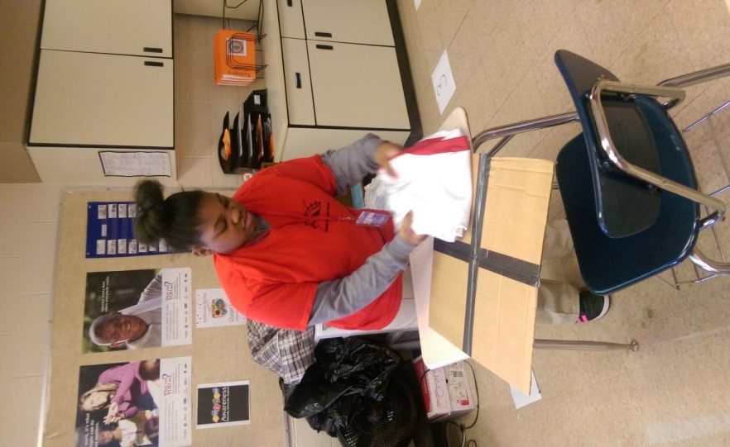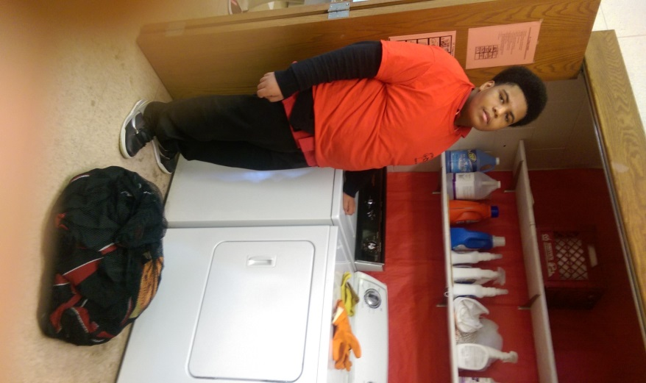
Student folding pants for the football Student preparing to load football uniforms
Team. Using a jig (folding accommodation into washer after completing inventory process.
Learned from Employment workshop/ASOC
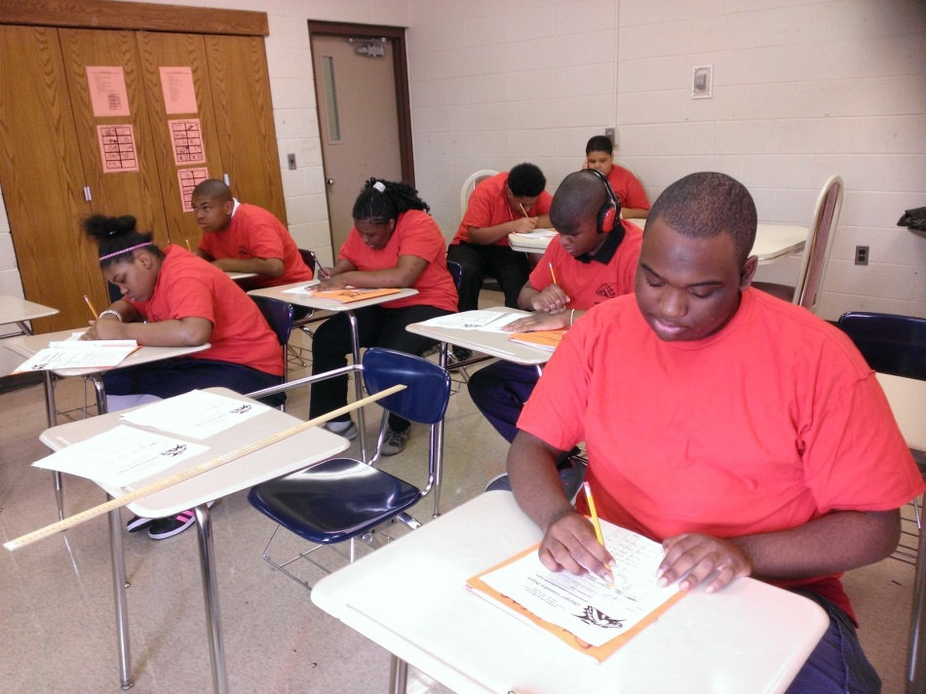
Students completing inventory paperwork

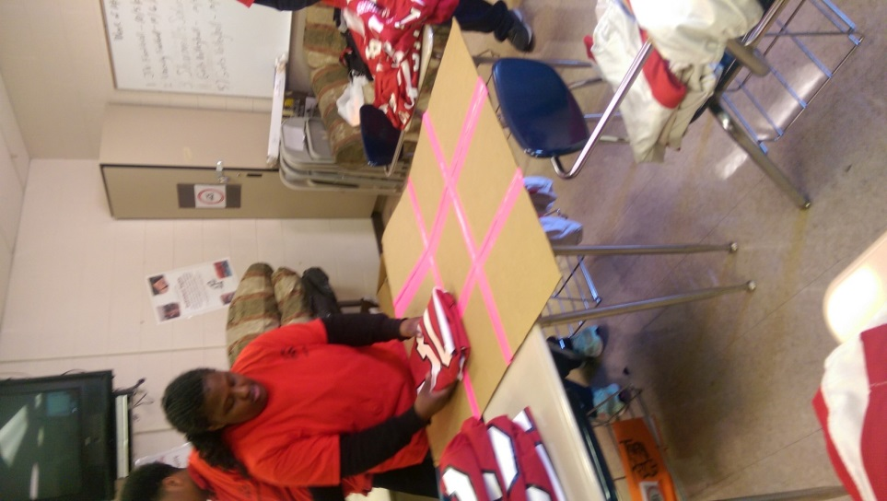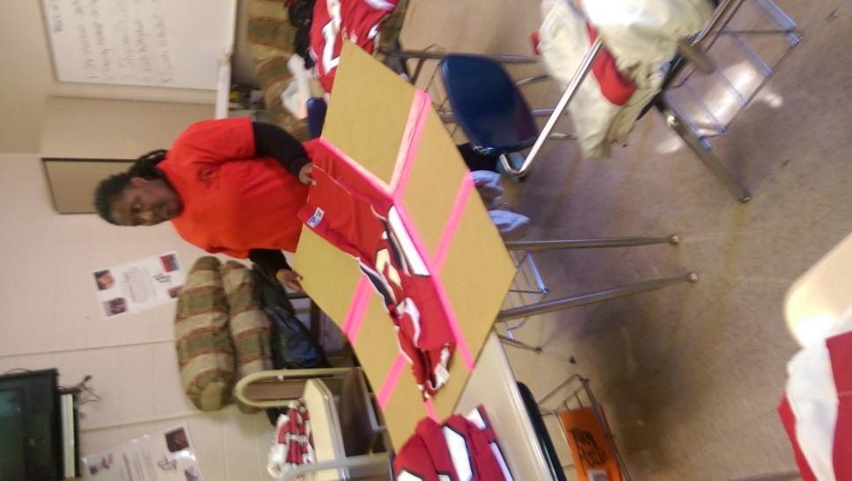
Student folding jerseys for the football
team. Using a jig (folding accommodation
learned from Employment workshop/ASOC
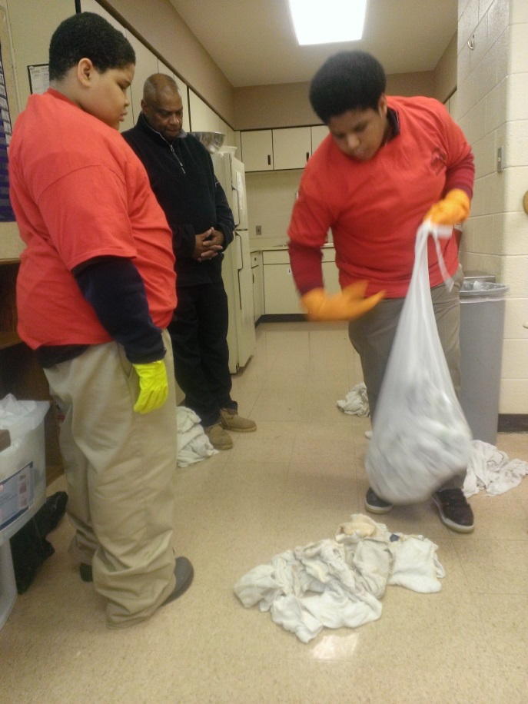
Students loading towels from Sharmell’s salon into
bags after the inventory process (sorting & counting loads)
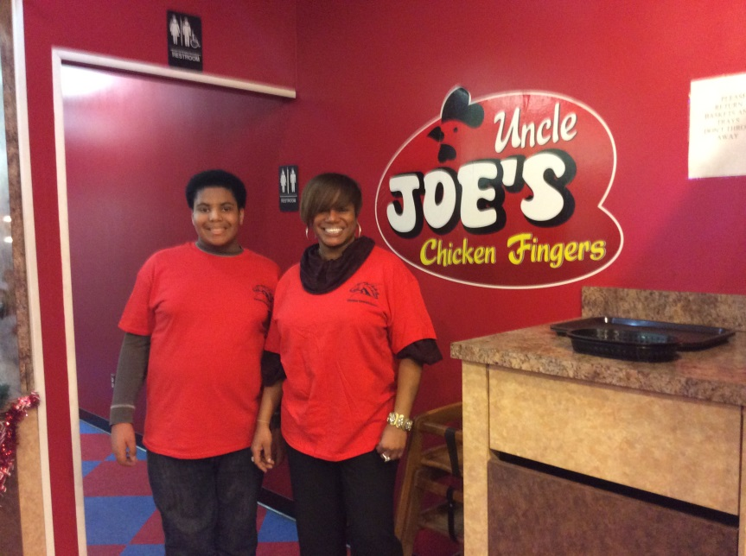
Student and Teacher (Levqual Robinson) at a community event
organized by the Charger Laundry Depot to promote laundry service and Autism awareness
Link to Charger Laundry Video
https://www.dropbox.com/s/wxj3lxc5lv0lapr/Autism%20Awareness%20Southfield%20Lathrup.mov

Link to Channel 4 News report on the Charger Laundry Depot
www.clickondetroit.com/news/job-skills-program-helps-autistic-children/32139024

Links to Media coverage on the Charger Laundry Depot
http://www.detroitnews.com/article/20140106/LIFESTYLE03/301060036/Mich-programs-help-position-autistic-students-success?odyssey=tab|topnews|text|FRONTPAGE

http://www.autismspeaks.org/news/news-item/programs-michigan-helps-students-prepare-life-after-high-school

http://www.hometownlife.com/article/20131222/NEWS20/312220006/Charger-Laundry-Depot-gives-autistic-Lathrup-students-skills-life

http://www.candgnews.com/news/new-program-helps-autistic-kids-business-skills

http://www.hometownlife.com/article/20140504/NEWS20/305040060/S-L-High-builds-autism-awareness

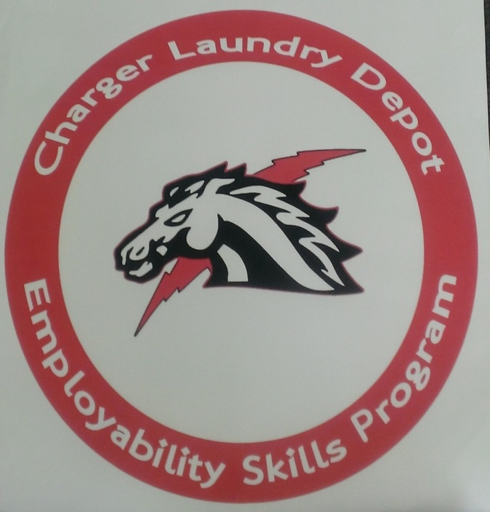
Put C

