Products and Services

→ Washing light loads for clothing

→ Drying light loads of clothing

→ Light ironing of clothing

→ Laundry cleaning solutions

**CHARGER LAUNDRY DEPOT**

*Self-Determination and Employability Skills Program*

◻ Freedom

◻ Authority

◻ Support

◻ RESPONSIBILITY

◻ Confirmation

**

Southfield-Lathrup High School

Southfield-Lathrup

High School

19301 W. 12 Mile Road

Lathrup Village, MI 48076

Phone: 248-746-7200

Fax: 248-746-4381

Email: levqual.robinson@southfieldk12.org

**Ms. Levqual Robinson, ED.S.**

**Coordinator**

**(248) 746-7200**

**Ext 6962 or 7460**

●●●

***Self—Determination***is the ability to decide how one wants to live his/her life. It is concerned with supporting our natural or intrinsic tendencies to behave in effective and healthy ways. It promotes financial competency, self-advocacy, concept of self, and self -awareness. Programs that promote self-determination give individuals with disabilities a chance to live a life with minimal support.

●●●

*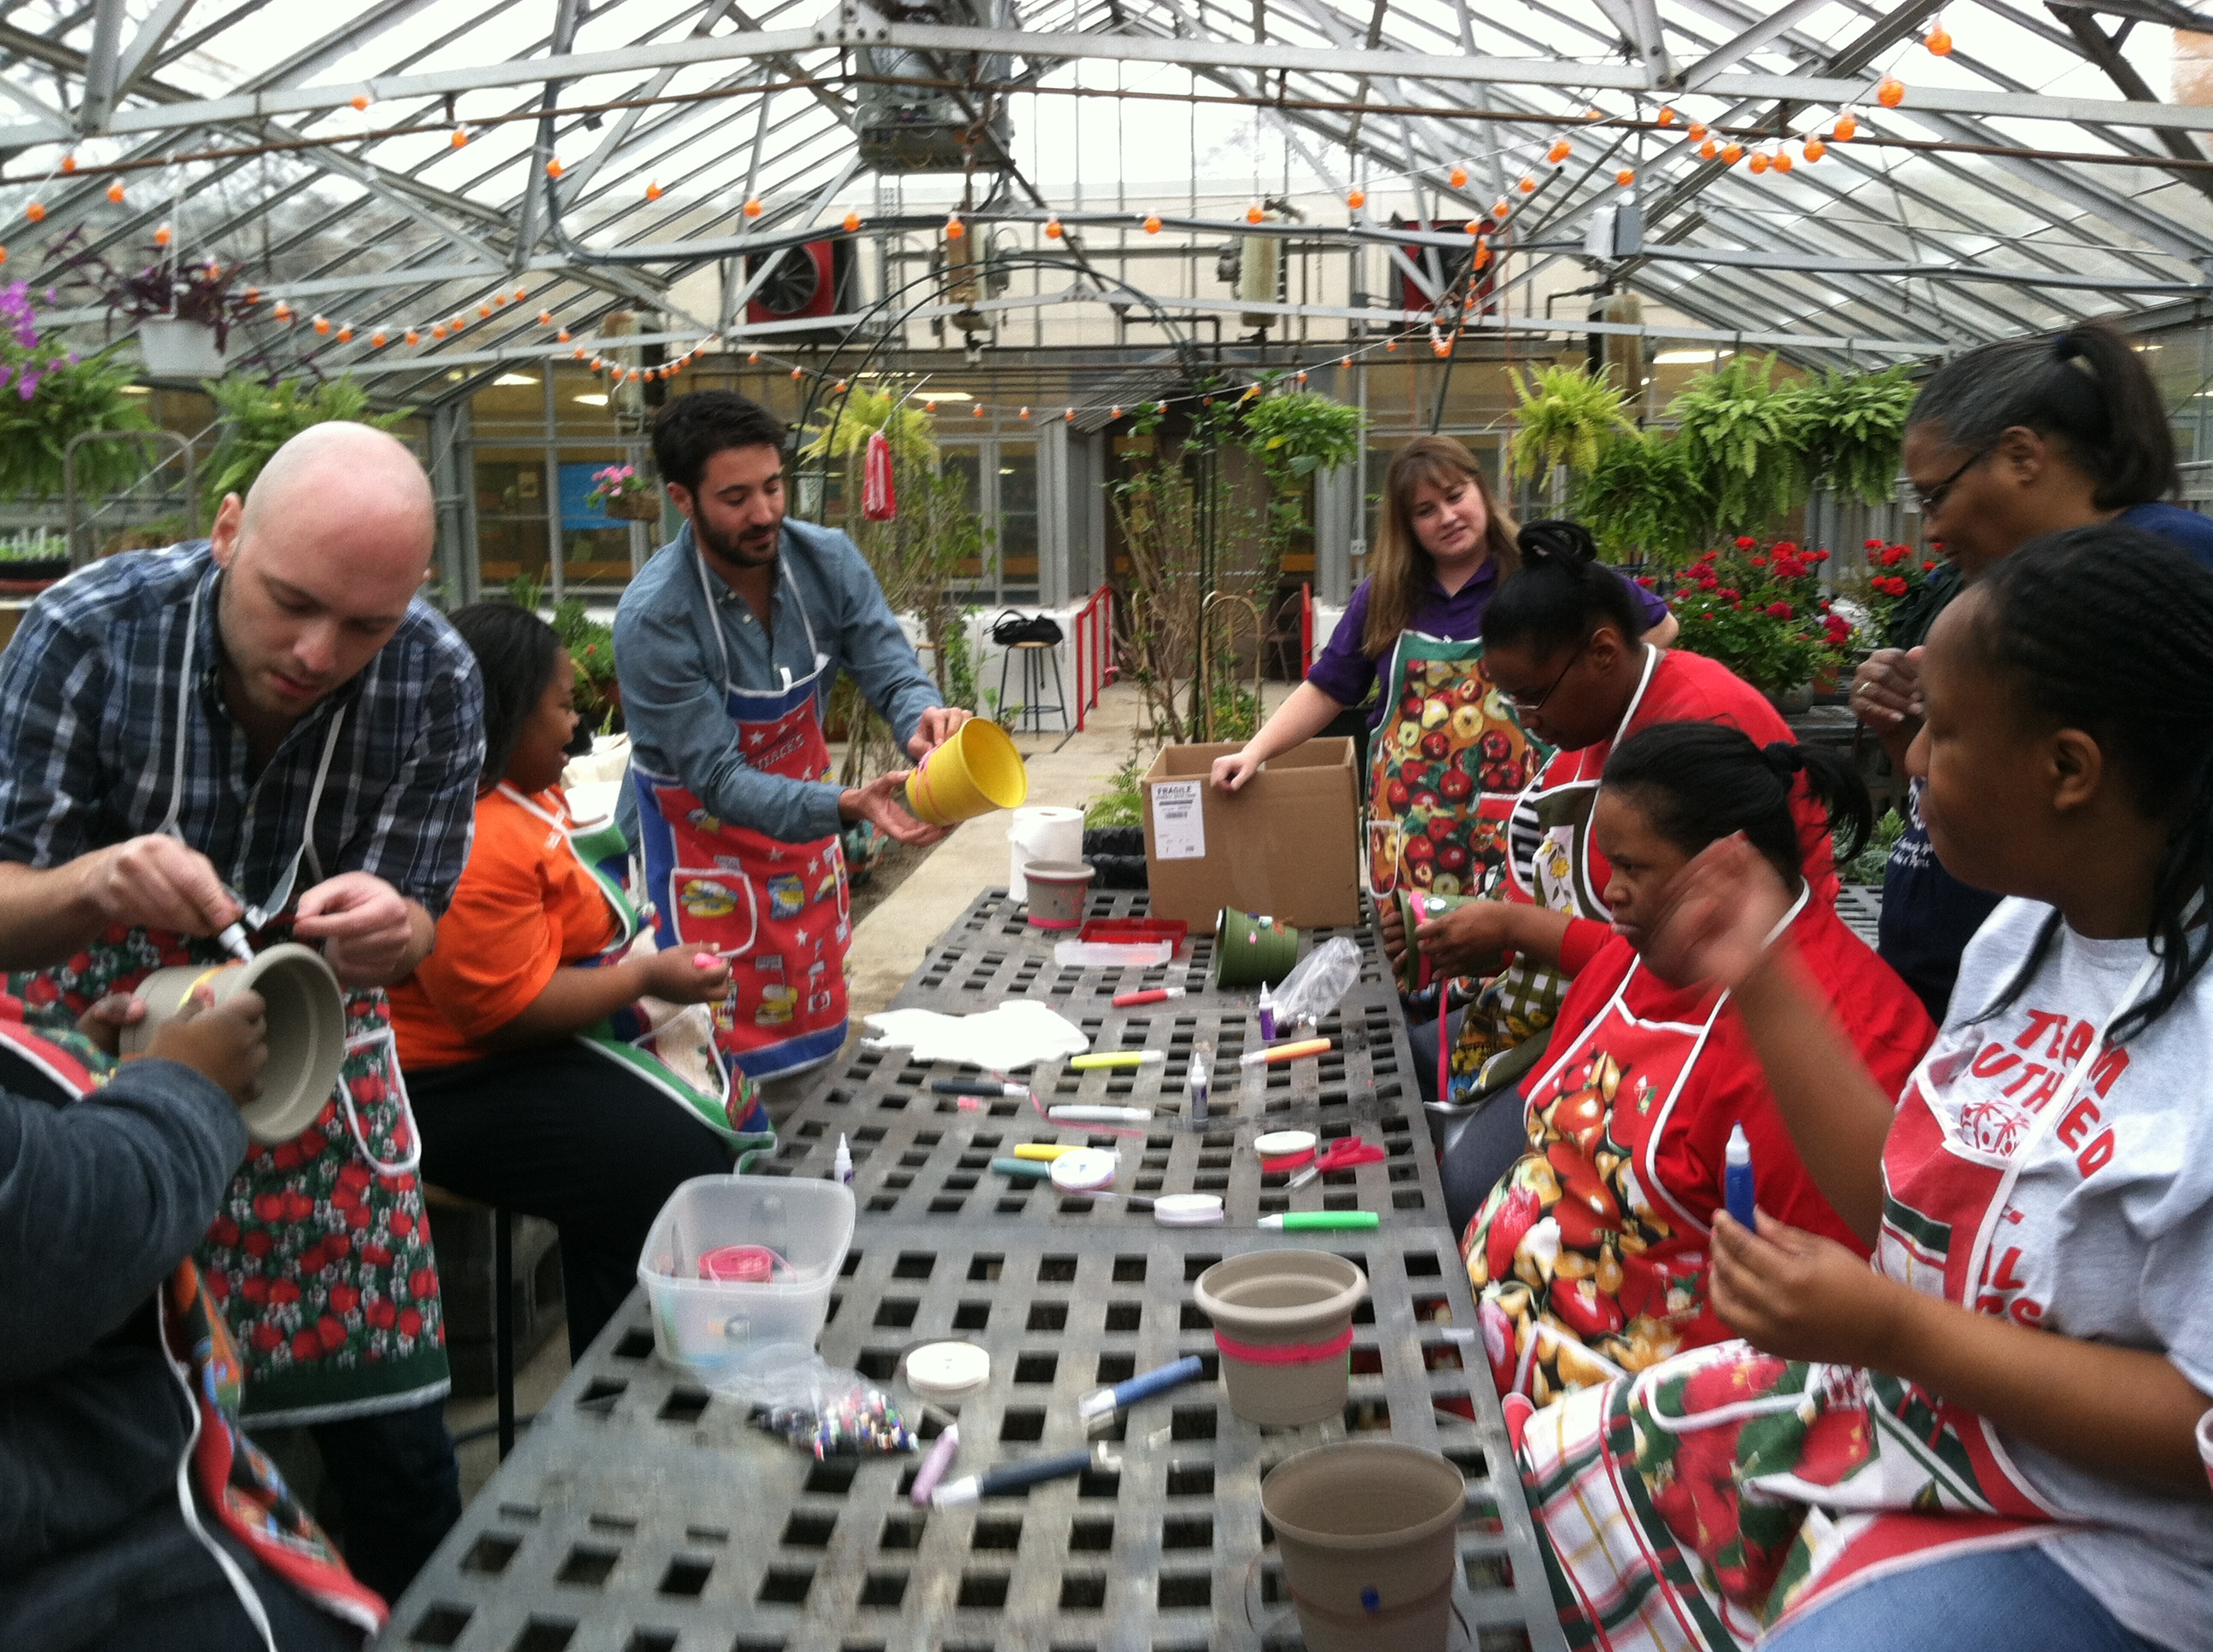 SLHS Charger Garden*

* SLHS Charger Athletics*

* SharMells Salon*

Charger Laundry Depot

community and beyond. These skills will give students experience and open up the pathway

Program Goal:

To increase employability skills and self determination practices

Student objectives:

* Apply basic communication, academic and technology usage in work related situations

Community Connections

* Display personal qualities such as responsibility self-management, self-confidence, ethical behavior and respect for self and others
* Work Cooperatively with people of diverse backgrounds and abilities and contribute to a group process
* Learn to monitor basic systems of operating a business and work with a variety of technology
* Integrate employability skills into behaviors which prepare one for obtaining, maintaining, advancing and changing employment
* Acquire information from career awareness and work-based experiences to identify and pursue their career goals

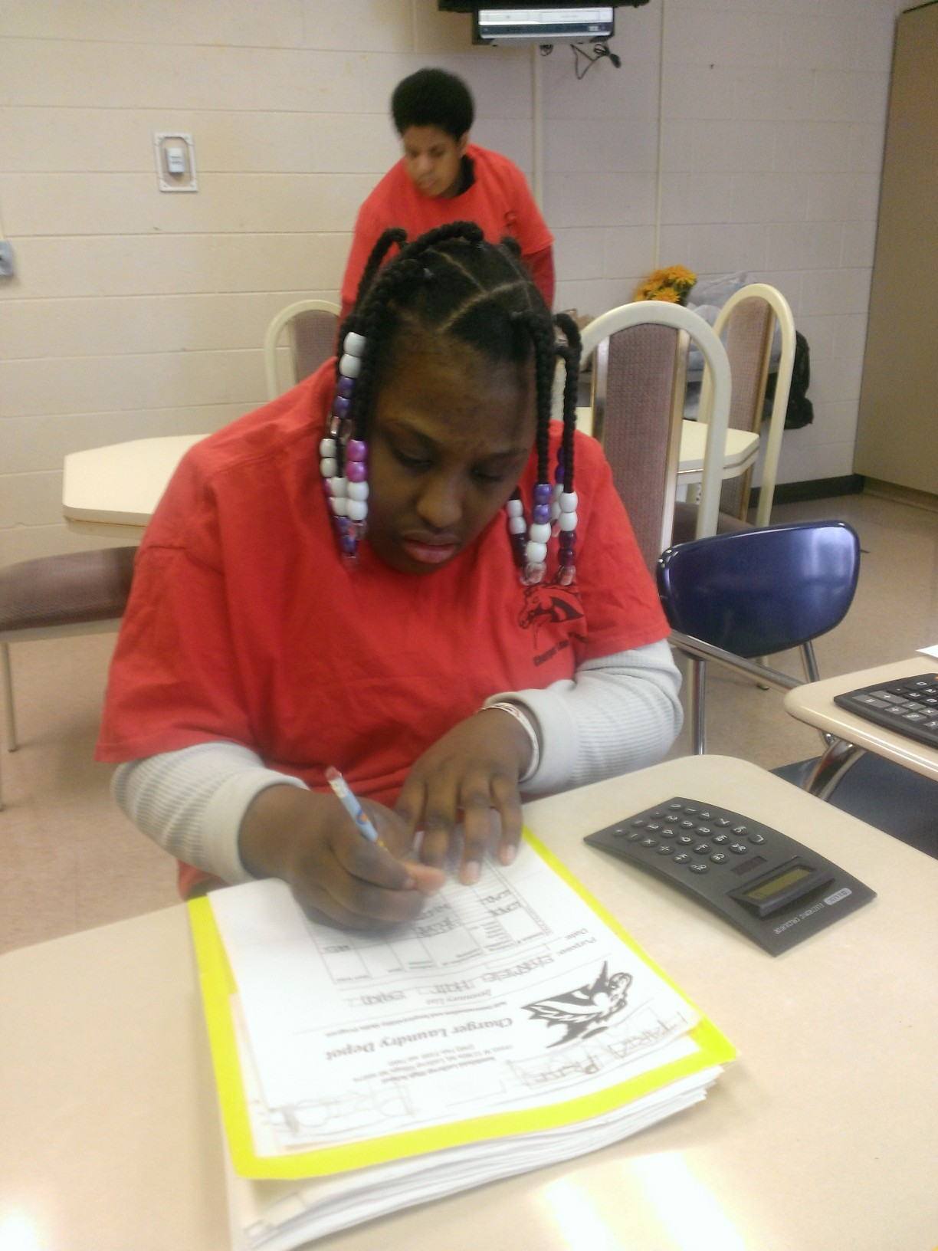

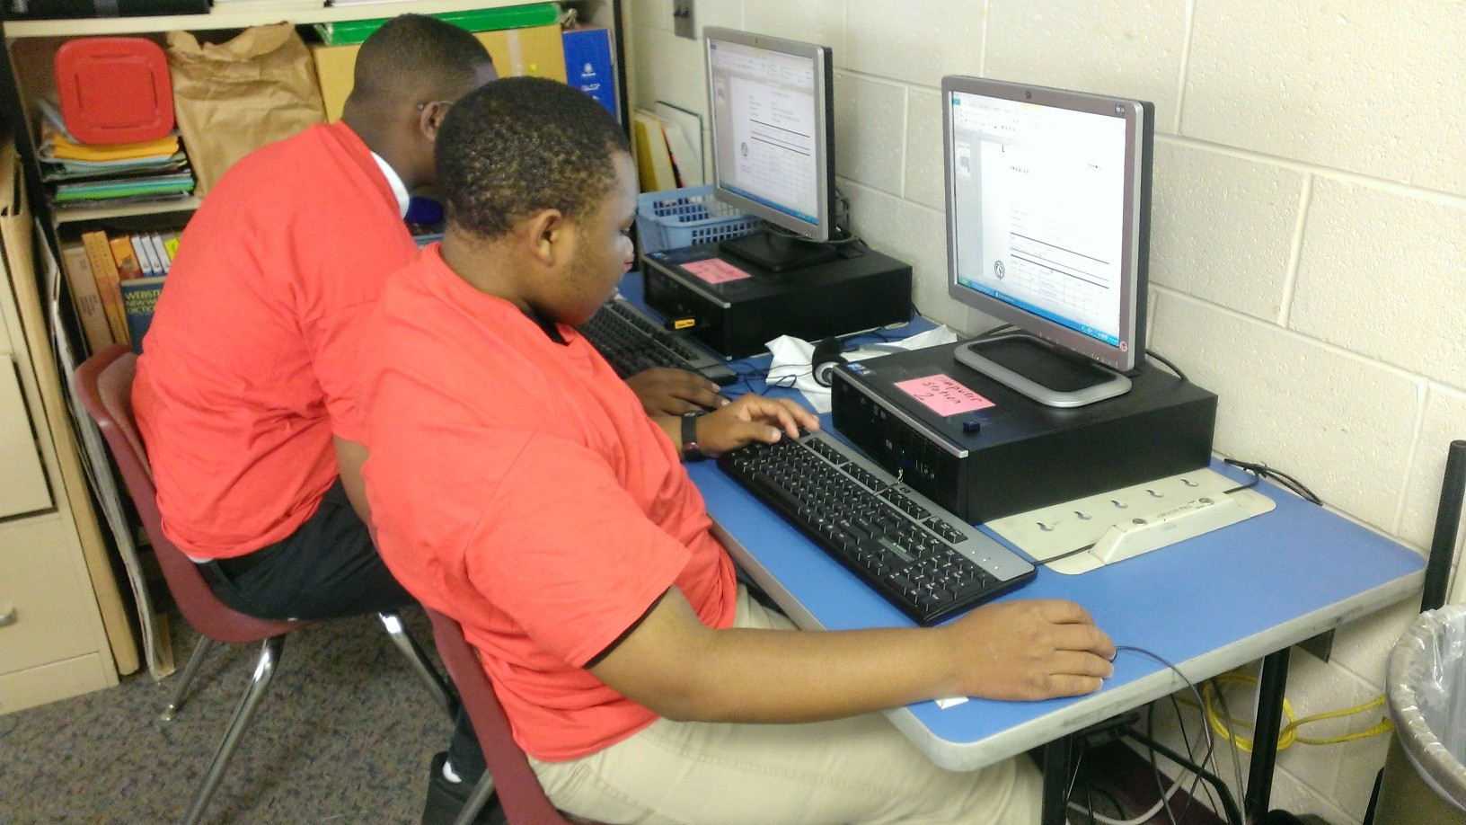

of thinking of how to pilot their own business and/or make informed decisions on future career .

Skills obtained will give students the ability to carry out real life job related responsibilities, interact with community, practice socially appropriate work habits, and enhance work ethics which will ultimately prepare them for the “world of work”.

The Charger Laundry Depot gives students with Autism Spectrum Disorders (ASD) and other disabilities opportunities to learn how to operate a cash register, receive goods to be serviced, process customer order, follow cleaning instructions, electronically maintain paperwork, as well as interact with non-disabled peers and other members of the school community and beyond.

About Us