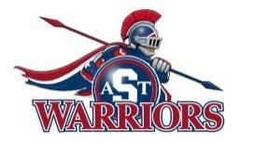
Southfield High School for the Arts and Technology
WEEK-AT-A-GLANCE
October 9, 2017-October 13, 2017
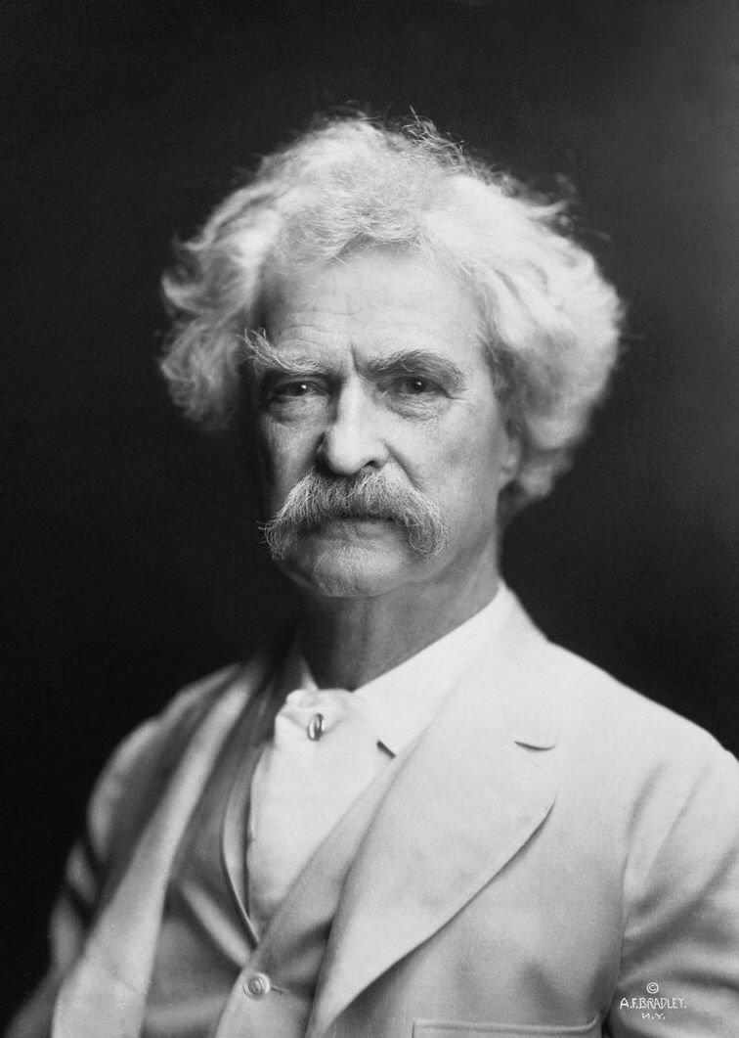
Monday, October 9, 2017
- Engineering Academy Activity Planning Session D 102,
3:00 PM – 4:30 PM
- Golf Practice, 3:45 - 5:15 PM
- Performing Arts Guild meeting 2:30-4:00 PM
- Senior Cap and Gown Pictures, ladies

Tuesday, October 10, 2017
- BPA Meeting, 2:30 - 3:30 PM
- Vocal Music Rehearsal 2:40 PM – 3:40 PM
- Girls Basketball – 3:00 -4:15 PM
- Algebra 1 tutoring w/ Mr. Eaton, 2:45 - 3:30 PM
- Art Club 2:40 - 4:30 PM
- Tech crew D 102 and Auditorium 2:45 - 4:45 PM
- Golf Practice, 3:45 - 5:15 PM
- Seminar - 9th Grade Chromebook training

Wednesday, October 11, 2017
- Man Up Meeting,
- GSA, 2:30 - 3:30 PM
- Poetry Club in rm B 221, 2:30 pm - Cancelled
- IVD Meeting D 102, 2:45 - 4:00 PM
- Golf Practice, 3:45 - 5:15 PM
- PSAT Testing - 9th 1-11th grades (Seniors, No school)
Thursday, October 12, 2017
- Parent/Teacher Conferences 3:00 - 5:30 pm and 6:30 - 8:30 PM
- Golf: Regional’s during school, time TBD
- Senior Cap and Gown Pictures, Gentlemen
- Seminar - 9th Grade Chromebook training

Friday, October 13, 2017
- Project Womanhood Meeting, 2:35 - 3:35 PM

PERSON OF THE WEEK: Samuel Langhorne Clemens, better known by his pen name Mark Twain, was an American writer, humorist, entrepreneur, publisher, and lecturer.
QUOTATION OF THE WEEK: “I have never let my schooling interfere with my education.”

