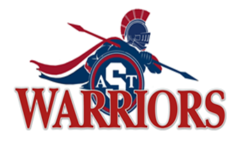
Southfield High School for the Arts and Technology
Senior Class Information

Date | Event
October 9, 2017 | Senior Cap and Gown Pictures - Ladies
October 12, 2017 | Senior Cap and Gown pictures – Gentlemen
October 12, 2017 | Senior Fundraiser Starts/ Southfield A& T Blankets
October 31, 2017 | Last day to purchase a senior jersey
November 27, 2017 | Jostens will be here to meet with students to discuss caps & gowns
December 5, 2017 | Senior Cap and Gown measurement - Ladies
December 6, 2017 | Senior Cap and Gown measurement - Gentlemen
December 22, 2017 | Yearbook ($60.00) Early Bird Special ENDS!
January 8, 2018 | Yearbook Cost $65.00
March 30, 2018 | Last Day to Purchase 2018 Yearbook
May 8, 2018 | May, 2018 Senior Event – Place TBD
May 31, 2017 | Prom - Place TBD
June 3, 2018 | Graduation will be held at Chene Park

Dues Information:
If Paid by December 15, 2017 - $125.00
If Paid by February 28, 2018 - $150.00
If Paid after February 29, 2018 - $175.00
I'll be using Remind to share class updates. Have a smartphone? Download the app here! http://rmd.me - Join by texting @ 2580kj to 81010.
Class meeting – November 27, 2017

Class Advisor: Ms. Karin Johnson
Email: Karin.johnson@southfieldk12.org

