VANDENBERG WORLD CULTURES ACADEMY PTA
Presents
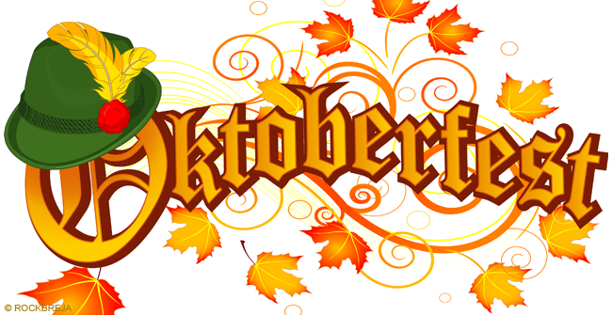
Where: Vandenberg World Cultures Adademy
When: Friday October 21, 2016
Time: 6:00 PM – 8:00 PM
Cost: $3.00 per person; $10.00 family of 4
$1.00 Food tickets $1.00 Henna tatoo art

Included
Activities: Face Painting, Pumpkin Decorating, Arts & Crafts, Exciting
Games, Balloon Animals, Popcorn and Goodie Bags

Notes:
- Each child MUST have an adult in attendance
- Children may wear costumes to Oktoberfest if they wish
- All children will receive a goodie bag at the end of the event
- Please send two bags of wrapped candy by October 18, 2016 with your child to help fill the goodie bags for Oktoberfest celebration. We are a NUT-FREE SCHOOL ZONE! Please do not send in any candy that has peanuts or nuts.
- We are still looking for parent volunteers for this event.

Students may purchase Oktoberfest tickets in advance and pick them up at “Will Call” at the event. Students may also purchase tickets at the door, during Oktoberfest. Please include this form when you make your purchase.
Cost: $3.00 per person; $10.00 family of 4
$1.00 Food tickets; $1.00 Henna tatoo art

Please check below what you would like to pay from in advance.

________ I would like to purchase _____ entry wristbands.

________ I would like to purchase wristbands for a family of four.

________ I would like to purchase ______ food tickets.

________ I would like to purchase ______ Henna tattoo tickets.

Total Cost: _________________

Student’s Name: _________________________________

Teacher’s Name: _________________________________

_____ Yes, I am interested in volunteering for this event.

Parent’s Name: ____________________ Phone: ___________________

