Spirit Week!! June 5th – June 9th
Please help your child(s) dress appropriately during sprit week
Monday – Cartoon/ Superhero Characters!
Wear your favorite cartoon or superhero t-shirt
Tuesday – College Wear!
Come dressed in your favorite college wear
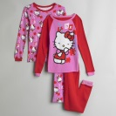 Wednesday – Pajama Day! 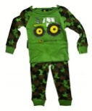
Come dressed in your favorite pajamas
Thursday – Twin Day!
Dress alike with your friends
Friday – Sports Team!
Wear your favorite sports team jersey or shirt
Happy Spirit Week!!
Team, Office 365. "Clip Art Now Powered by Bing Images." Office Blogs. N.p., 02 Dec. 2014. Web. 24 May 2017.

